Introduction.
Jason Sen started his career in financial markets in April 1987 at the age of 19 years.
My first job was at a large stockbroking company in the city of London called Sheppards and Chase. I arrived on my first day in my brand-new suit and shoes, to their huge shiny offices at Number One, London Bridge. I had no idea what my job would involve and on my first day I was extremely surprised to be taken straight down to the floor of the London stock exchange. Since ‘Big Bang’ shares were no longer trade on the floor, they were traded from offices over the telephone. Electronic trading was still a thing of the future in those days, but market-makers could advertise their prices on screen on a stock exchange network.
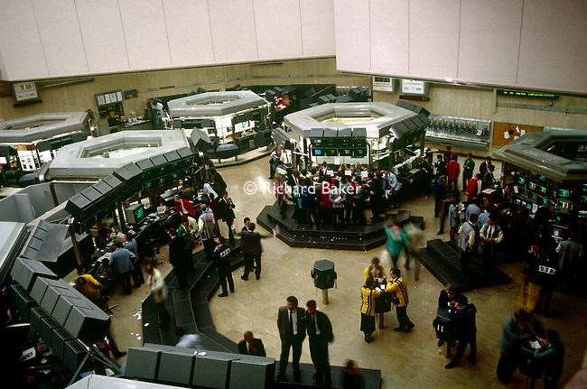The LTOM on the floor of the London stock exchange in the late 1980’s.
The London Traded Options Market was a new market and the only open-outcry market to operate on the floor of the London stock exchange in 1987. The brokers each had a booth with banks of direct telephone lines to their clients. My first job was to process the order tickets that were written out by the telephone brokers and given to the floor traders. The market was growing extremely rapidly and within a short period of time, I was promoted to a phone broker. The phones did not ring, a light flashed and I had to click the button within a fraction of a second, or the aggressive trader at the other end of the line would scream at me for taking too long. He would bark an order at me, I would repeat it back to him, no ‘hello’ or ‘goodbye’, and he would click out. I gave the order tickets to the floor broker to be executed.
It was only a matter of months before I was then promoted again to floor broker. Just as I was getting a bit of confidence, I was about to experience the most frightening time of my life. I had to walk into a ‘pit’ of loud, confident and aggressive men, all determined to be the first to trade my order for the opportunity to make another large sum of money. I was petrified and I would tremble every time I walked near the pits for weeks.
Then the October crash of 1987 happened and all hell broke loose. There were not enough hours in the day to execute all the orders we were given. It was an incredible experience to witness a week of panic in the financial markets, but by December I had been made redundant as the volume traded collapsed.
I thought that was the end of a very short career in the financial markets, but I was lucky enough to receive a job offer from a Dutch market-making company as a trainee. It was a small, privately funded company, owned by the boss’ father, who had sent his son to open an office in London. He was one of the biggest traders on the floor and this was an enormous opportunity for me to learn how to trade options.
In those days there were no training programs, you learned by standing in the pit and making mistakes. Eventually I started to do okay and I got a job offer from another company who wanted me to trade on LIFFE.
The London International Financial Futures Exchange was second only to the Chicago Board of Trade. This was where the real action happened and it made the London traded options market seem tame.
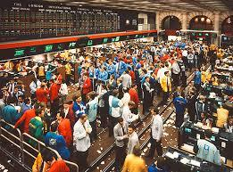
The open-outcry trading floor of LIFFE in the Royal Exchange, the early 1990’s.
It was a lot brighter, a lot louder, the traders were far more aggressive and it was a lot more exciting. The colours alone were dazzling.
It was frightening to walk on the trading floor for the first time. Traders were screaming and shouting in each others faces, waving their hands in a frenzy, and using hand signals to communicate. I had absolutely no idea what was going on, despite the fact that I been working on the trading floor across the road. This was like landing on another planet. It was obvious that I would have to start learning how to trade all over again.
Eventually I learned all the hand signals and passed the exams, so I was ready to go into the option trading pit as one of the market-makers. The LIFFE traders made the LTOM traders seems like very polite City gents. For these guys a big part of the game was intimidation. They did not want any more competition in the pit and they would do everything they could to frighten you away. I was just a timid boy, educated at a private school and I had to completely change who I was in order to survive.
I became aggressive, rude, cocky and every second word that left my mouth was a swear word but this ended up being one of the greatest experiences of my life. I really was in the right place at the right time, in my early 20s in one of the most exciting environments on the planet, with the opportunity to make huge sums of money. The guys in the pit were extremely intelligent, could react in a split-second, they had to fight for every penny they made and there were no computers, charts or calculators. You lived on your wits and your guts.
They were also very sharp-witted and in the quiet periods when we weren’t trading, we would have a lot of fun. I loved this testosterone filled environment and I met some fantastic people, many of whom are still some of my closest friends to this day.
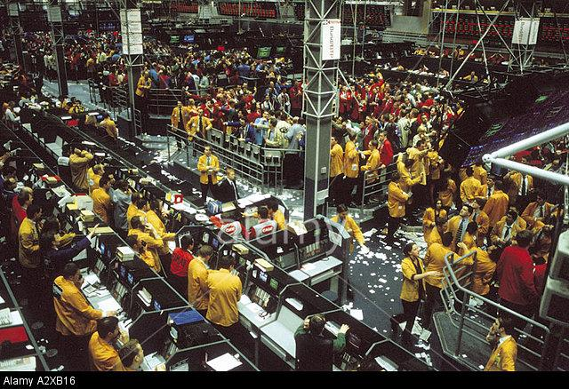 The open-outcry trading floor of ‘new’ LIFFE in the mid 1990’s at Cannon Street.
Module 1: Basics of Technical Analysis
Philosophy of Technical Analysis
There has long been discussion over whether the markets are random or cyclical with evidence from both sides to prove the other wrong.
The random walk hypothesis states that markets follow an efficient path, where no form of analysis can provide a statistical edge and will not follow any patterns or trends, and that past price movements cannot be used to predict future price movements.
The Efficient Market Hypothesis states that at any given time, security prices fully reflect all available information and evolve according to a random walk. The implications are that most individuals that buy and sell securities (stocks in particular), do so under the assumption that the securities they are buying are worth more than the price that they are paying, while securities that they are selling are worth less than the selling price. But if markets are efficient and current prices fully reflect all information, then buying and selling securities in an attempt to outperform the market will effectively be a game of chance rather than skill. There is a huge amount of evidence produced to support this theory.
Ironically efficient markets depend on market participants who believe the market is inefficient and trade securities in an attempt to outperform the market.
The other side of the fence is the non-random walk theory. Fundamental and technical analysts believe that there is a certain rhythm to the markets that careful analysis can help to uncover, providing at least a slight advantage. Day traders in particular, believe in the non efficient market hypothesis and believe they can beat the market which is why they trade short term moves in search of profit. We believe that the market can be predictable to a small degree, enough to help us reduce risk and increase reward in our favour.
Fundamental analysis focuses on news events and the overall state of economies, taking in to account economic indicators and forecasts which are released on a daily basis. Traders may also consider the health of individual companies and sectors to help them decide what news and events will dominate the market at any particular time and form a basis for their strategy to make a profit.
Technical analysts believe we can spot trends and patterns from historical data that provide lower risk entry and exit levels on a trade. My belief is that market price is determined by the interaction of supply and demand both rational and irrational. Technical analysts know that financial markets tend to move in trends that persist for an appreciable length of time and therefore if the trend can be spotted at an early stage using the appropriate tools an edge can be gained and a trade can be held until the trend is deemed to have ended. Many of these trends will repeat over time in a rather consistent manner.
We believe that changes in a trend are caused by the shifts in supply and demand and that is does not matter why they occur, only that they do occur and that they can be detected sooner or later using charting techniques.
Technical Analysis therefore is a useful tool in the forecasting of future price of financial markets, based on historical price movements. Like weather forecasting, technical analysis is not perfect and will not produce 100% certainty about where the market is going or in what time period, but it can help traders anticipate what is "likely" to happen in the future using a variety of charts that show price over time.
Technical Analysis was established when the system of pricing goods on the open market first began in Japan as early as 18th century. However, most of its methods as we know them today were created in the first decades of 20th century and have been used by an increasing number of professional traders, including those at major banks and funds who regularly publish the findings of their analysis for the benefit of their clients.
Technical analysts, sometimes also called chartists, believe we can gain a clearer idea of the current "psychology" of the market through historical price action displayed on charts. Patterns on these charts can indicate the flow of demand and supply and which side will likely prevail and we believe that these patterns will repeat themselves in future price action.
The field of technical analysis is based on three assumptions:
1.The market discounts everything.
2. Price moves in trends.
3. History tends to repeat itself.
1. The Market Discounts Everything
Technical analysis does not require constant monitoring of fundamental information as it only considers price movement. It is assumed that, at any given time, the price of an instrument already reflects everything that has happened or could affect the outlook, including fundamental factors. For example we believe that a company's fundamentals, along with broader economic factors and market psychology, are all priced into the stock by participants, removing the need to actually consider these factors separately.
This is a big advantage and time saving assumption because we only need to monitor price movement and volume traded, which technical theory views as a product of the supply and demand of a stock or financial instrument.
Fundamental analysis would try to estimate a company's intrinsic value to determine whether it's stock was a good or a poor investment. A technical analyst is not concerned with value in the same way, but the likely future price movement of its shares instead and does not care for the fundamental reasons why this happens.
Moreover, technical analysis can be applied to practically every financial market (equities, bonds, commodity futures, currencies, etc) without having to trawl through pages of economic or company reports. Only a charting package providing historical data for the required instrument or stock is necessary and these are very affordable and accessible to anyone with a PC.
2. Price Moves in Trends
One of the first things a technical analyst will try to spot is the trend of the market because after a trend has been established, the future price movement is more likely to be in the same direction as the trend than to be against it. Most technical trading strategies and many algorithmic black box systems are based on this assumption.
It is often assumed that prices either trend upwards or downwards but prices also can spend a lot of time in a 'sideways' trend or moving with in a range. Many traders simply look for markets that are trading within a range and wait to enter and exit the market at either ends of the range.
However, there are more often then not, several trends which can be more clearly seen over different time periods. For example, in a monthly chart we can find a long-term trend, which actually consists of many smaller trends. We can then observe the weekly, daily and intraday chart which may be 4, 2, 1 hour or less. It is possible that different time periods will have contrasting trends.
Trading in the direction of the trend means you start by determining direction of the long-term trend and then gradually move to lower time frames, but the key trend to watch should be the one corresponding to the time horizon during which you want to have the position open.
3. History Tends To Repeat Itself
The repetitive nature of price movements is attributed to patterns in human psychology that do not change as market participants tend to provide a consistent reaction to similar market stimuli over time. Technical analysis uses chart patterns to analyze market movements and understand trends. Although many of these charts have been used for more than 100 years, they are still believed to be relevant because they illustrate patterns in price movements that often repeat themselves.
There are many different types of approaches to technical trading and the most commonly used methods can be divided into two sections
1. Pure chart analysis where we try to find recognised patterns that occur repeatedly. For example, 'head and shoulders' or 'double bottoms' are considered typical chart patterns and ones that can work well to give a trader an edge offering a low risk trading opportunity, based on the direction the price should follow depending on the type of the pattern.
2. Technical indicators and oscillators such as Relative Strength Index (RSI), Moving Averages and Stochastic Oscillator, can sometimes give an indication of the underlying strength or weakness in the market. Most traders use some combination of the two.
‘Success depends upon previous preparation, and without such preparation there is sure to be failure’.- Confucius
Basics of Charting

Types of Charts - Understanding how to read the line, bar and candle stick charts.
There are three basic types of charts use by technical analysts to read historical price action. The first was used quite a lot when I first started in the industry back in the 1980's and is called a line chart. In those days the Internet did not exist and many analysts actually plotted charts by hand on graph paper. It was in fact my father who got me interested in this business, and he would sell-o-tape pieces of graph paper together and manually plot the closing price of the FTSE 100 index with a pencil and join up the dots each day. This was useful for spotting the prevailing trend, but the line chart is no longer used by technical analysts, now that we can download data in less than a blink of an eye.

The next step up from a line chart is the bar chart. Each bar represents a period of price action with the open, the high, low, and the close. For example, on a daily chart, the small line appearing on the left of the bar indicates the opening or first traded price. The low of the bar is of course a low of the day and the high of the bar is the high of the day. The small horizontal line appearing on the right of the bar indicates the closing or last traded price of the day.
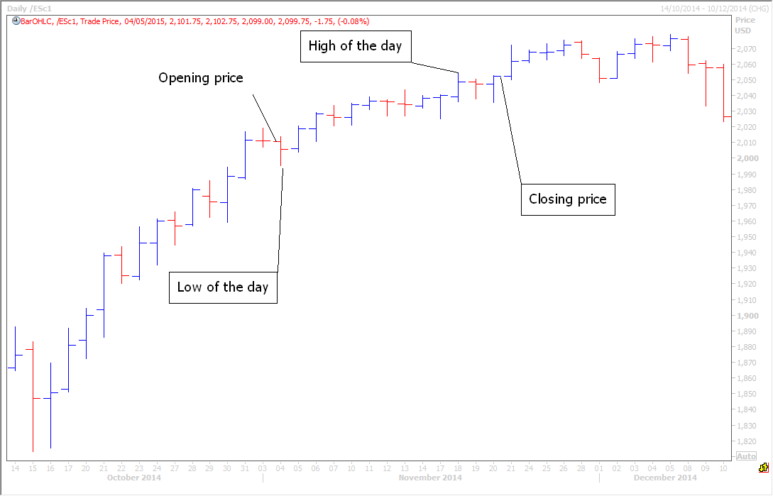
Anyone can now obtain accurate historical data for free on the Internet or through a broker. Many trading platforms include free charting packages which could be good enough for a short-term, day trader.

The Japanese candlestick is now the most widely used chart amongst traders and analysts. The candlestick takes the bar chart a stage further by creating a body within the bar between the opening and closing price. The body of this candle is given a colour, usually blue or green, if the closing price is above the opening price, or red if the closing price is below the opening price. The wick of the candle appears above and below the body, indicating the high and the low of the day in exactly the same way as the bar chart. Often the colour of the wick matches the colour of the body. By just glancing at the candle you can see the day's range and if the price had a significant move from the opening to the closing. It's also very easy to quickly see where the price opened in relation to the day's range and where it closed in relation to the day's range. All this information when put together on a chart and compared to the candles of previous days can give clues to future price action.

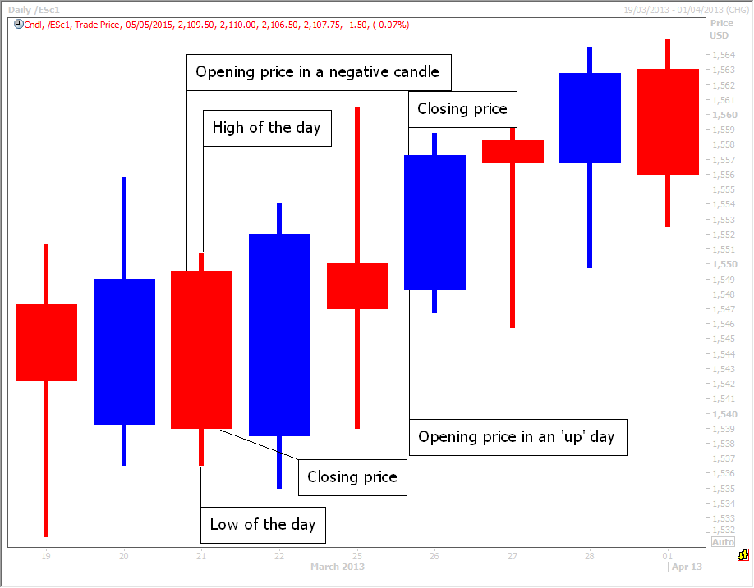
At first glance this can help not only to give an indication of the trend, but also the momentum within that trend. For example, if we are in a positive or bullish trend and the candles within that trend have big blue (or green) bodies, this indicates strong positive momentum within that trend. If the candles have only very small bodies with long wicks this tends to indicate more indecision on the part of market participants and may be a sign that the bulls are losing control, meaning the positive trend may be running out of steam in the short-term at least.

Support & resistance
The key to successful day trading is mastering the principle of trading support & resistance.

The most successful traders in the world I am sure would have to admit they could not predict where the markets will go on an intraday basis, day after day with any degree of accuracy. It is incredibly hard to predict short term price movement, hour to hour or with a 24 to 48 hour period....even within a week or a month. What successful short term day traders do to make profits on a daily basis, is look for the important levels in the market where they can enter low risk trades. These support & resistance levels are where the market is likely to pause & perhaps reverse.
A support level is a price level where the market tends to find support as it is experiencing a correction in a bull trend. This means the price could very well "bounce" off this level rather than break through it and is more likely to do so the first time it tested. However, once the price has passed below this level, perhaps on the second or third test it is likely to continue dropping until it finds another support level.

A resistance level is the opposite of a support level. It is where the price tends to find resistance as it is going up, especially in a bear trend. Experienced traders tend to wait to sell at resistance & buy at support as this gives them the best trading edge.

If price is moving between support and resistance levels, therefore traders buy at support and sell out for a profit as the price approaches resistance. They also sell short at resistance and cover the short (buy back for profit taking) as the price approaches support.

How do I correctly identify key support & resistance levels on a chart?

The most basic way to spot a support or resistance level is to look back for areas where prices tended to stabilise for a period of time. In the chart below the short pink lines indicate areas of support or resistance, where price has stalled. These areas will often work again in the future when retested. It is worth making a note of these levels and perhaps creating a list to use as a reference point. The purple lines show how these support and resistance levels can work well into the future.
An important point to note is that once a support level has been broken, it tends to act as resistance. Day trading is a psychological game and if you have watched the price bounce at a particular level several times, this price level will tend to stick in your mind. This has an effect on many of the market participants and they will judge this as an area to enter or exit trades in the future. When a resistance level is broken, it also tends to act as support.
Think of it like this. At any one time there are traders with long positions and opposing traders with short positions. If, for example, the EURUSD traders holding longs noticed that the price has been supported at around 1.1030 for two hours, many may feel comfortable as long as that level holds and decide to put a stop loss in just below at 1.1010. If the level is broken and many traders are stopped out of the long position they will have that 1.1030 level imprinted in their minds over the next days. If the EURUSD were to fall a little bit further, and then bounce back up to the 1.1030 level those traders that was still holding longs would see that as an opportunity to exit their positions for almost no loss. Those that were stopped out of their longs with see this area as resistance to try shorts and see if the EURUSD moves back down again.
The traders with short positions may be happy that the market is trending in their direction. They will also remember that 1.1030 acted as support on the way down. They may decide to add to their short positions at this level. All these market participants will reinforce this area as resistance on the bounce.
This is why areas of support and resistance, such as in the chart below, continue to work over and over again.

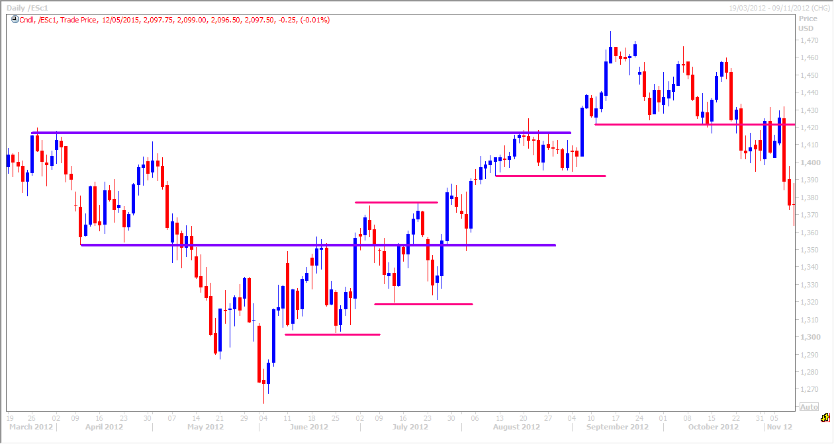
Module 2: The trend is your friend.
Technical analysts markets constantly move in one of three trends:
- Up or Bull trend
- Down or bear trend
- Sideways trend
We must define the overall trend of the market for the time period in which we are trading, so that we can execute trades within the direction of the trend. As markets do not trend in one straight line, some trend analysis is required. A trend is not like a bullet fired from a gun which moves quickly in a straight line. It is far more like a dog wandering down a long street. The dog will meander all over the road pausing at various points even retracing some of its steps before continuing on its journey to its final destination at the end of the straight road.
- Bull (up) trend.
The key point is that for a positive or bull trend to be maintained, each new major peak will be higher than the previous peak and each new trough (or low point of a pullback) will be higher than the previous.
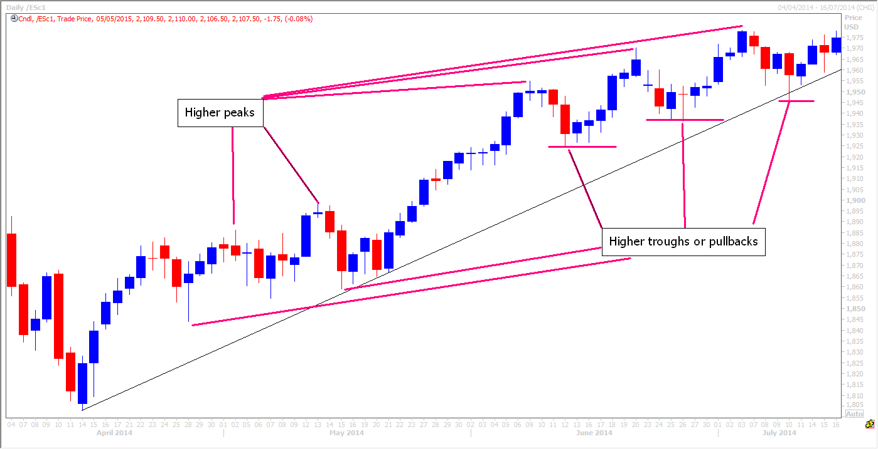

- Bear (down) trend
The reverse is true for a negative or bear trend. Prices move in a generally downward direction. The new peaks are unable to match the previous peaks and the new troughs reach continuously new lows.

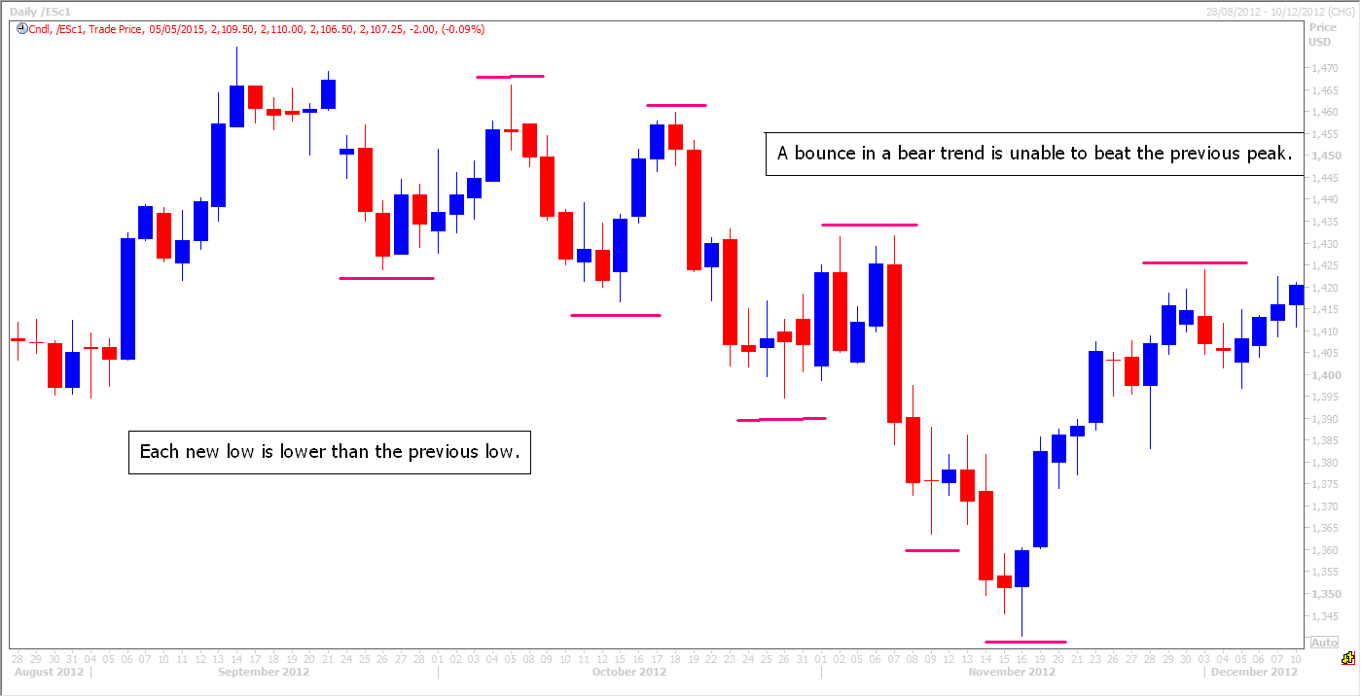
C. Sideways trend.
When price is not trending upwards or downwards it is trending sideways. This still counts as a trend when markets lack no clear upward or downward direction. It is important to recognise a sideways trend as soon as possible because there are good low risk trading opportunities to take advantage of. In the chart below the red box represents a sideways trend that lasted about six weeks. It can be relatively easy to trade this trend, because you can just leave orders to buy around the bottom of the range and sell around the top of the range. We will examine how to trade a sideways trend, as well as a bull and bear trend, in more detail later in the course.

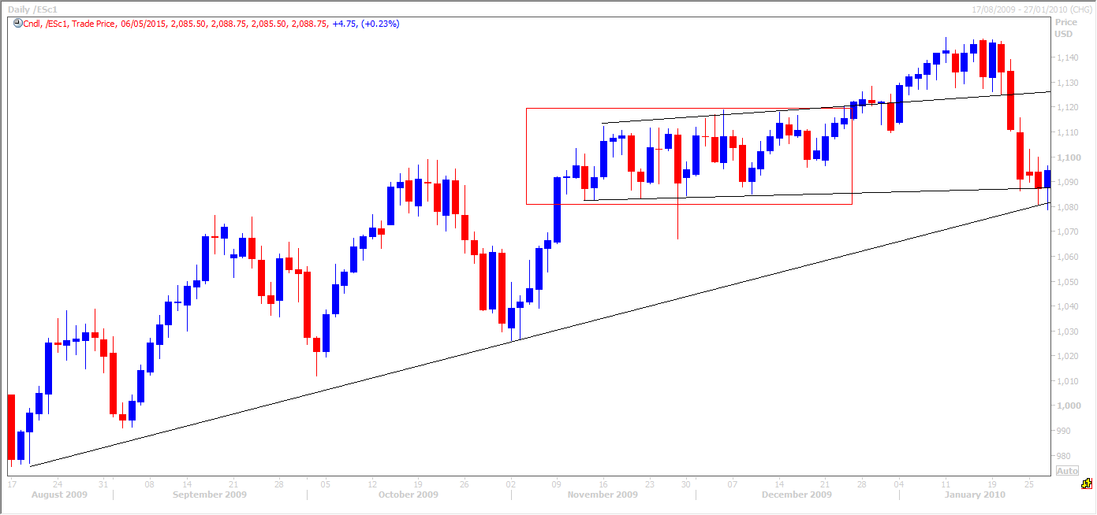

Using trend analysis to determine the trend.
To help clearly establish which way the market is trending analysts and traders use trendlines and moving averages.
Trend lines
When you first look at the chart it may appear obvious that joining up various highs and lows will create reliable trendlines. A trendline is simply a straight line that connects two price points and then extends into the future, but you have to stick to certain rules. It is very easy to draw incorrect trendlines which would be unreliable.
An uptrend or bull trendline connects two or more low points in the trend and therefore slopes upwards. This trend can be used as a support level, as price will generally bounce off this line if the trend is to be maintained. Buying at a support level in a bull trend is a key trading strategy.

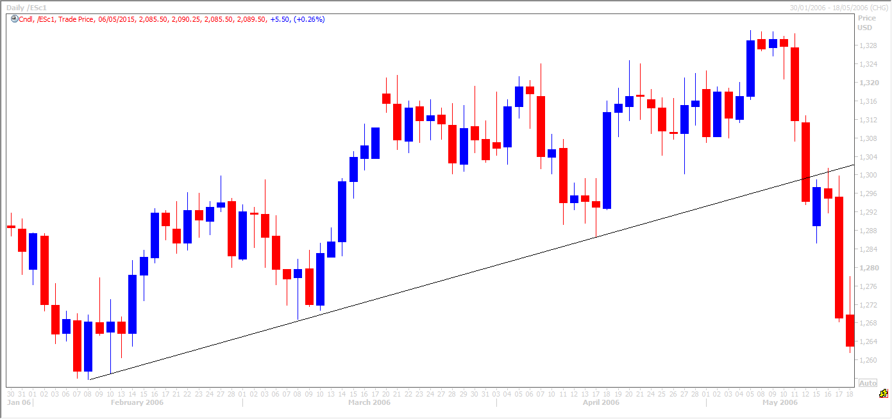
The chart above shows a correctly drawn trend line. Two significant consecutive low points have been joined on the left-hand side of the chart. This has pinpointed a clear support level when the trendline is tested for the third time. A buy order at this price point would have created a very profitable trade.
Uptrend lines act as support when the market hits a bout of profit taking and indicates that buyers are prepared to pay increasing prices because each successive low is higher than the last.

Note that a well established trend line which has held at least 3 or 4 times in the past is only then considered broken if price CLOSES outside of the line. A well established trend line can be tested with a spike above or below as ‘stop-hunters’ try to shake out the weaker traders and force them to stop out of positions, but the price can then recover to close just above the trend line in a bull trend or just below it in a bearish trend line. This not only signals a false break, but also that the trend remains intact.

The chart below shows a blue trendline which is drawn incorrectly. The line does not connect to significant consecutive low points and is no use in deciding where to execute a trade. The red line however clearly joins two significant consecutive low points and works many times as a support level into the future.
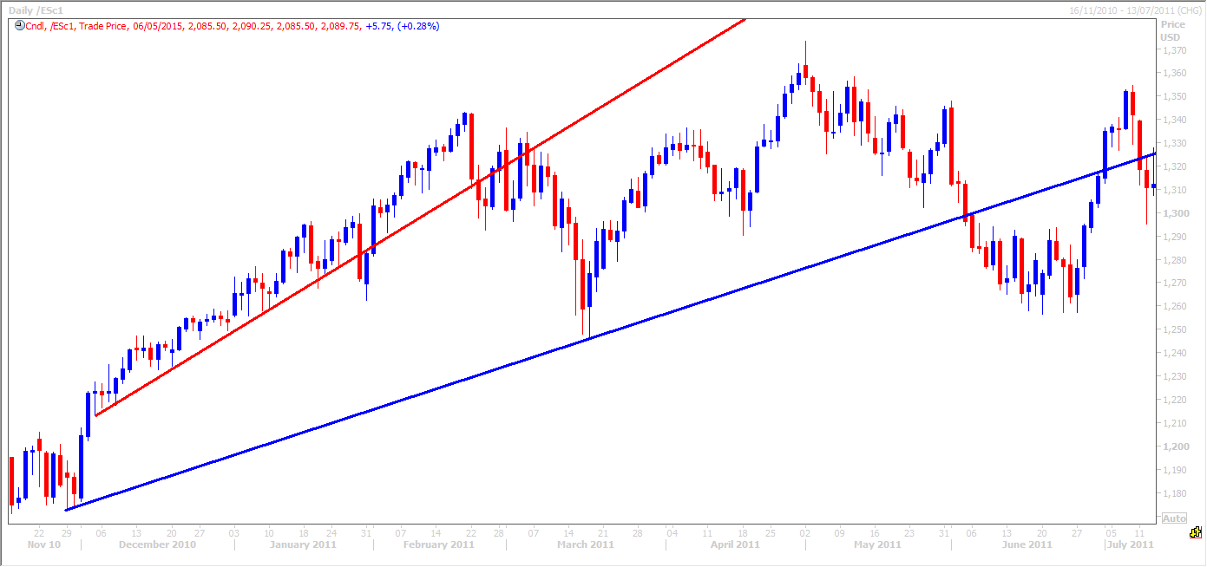
A key point to note is that the more times a trendline is tested the more its strength is reinforced and considered reliable. In the example above, the red trend line was tested, perhaps a dozen times in the early part of this trend, offering many potential profitable trading opportunities.

As you might expect a bear trendline works in reverse. Two significant consecutive high points are connected with a straight line to the left of the chart in the example below. The trendline continues to work very well as a resistance level, and selling at or just below this trendline would have created several profitable trades.
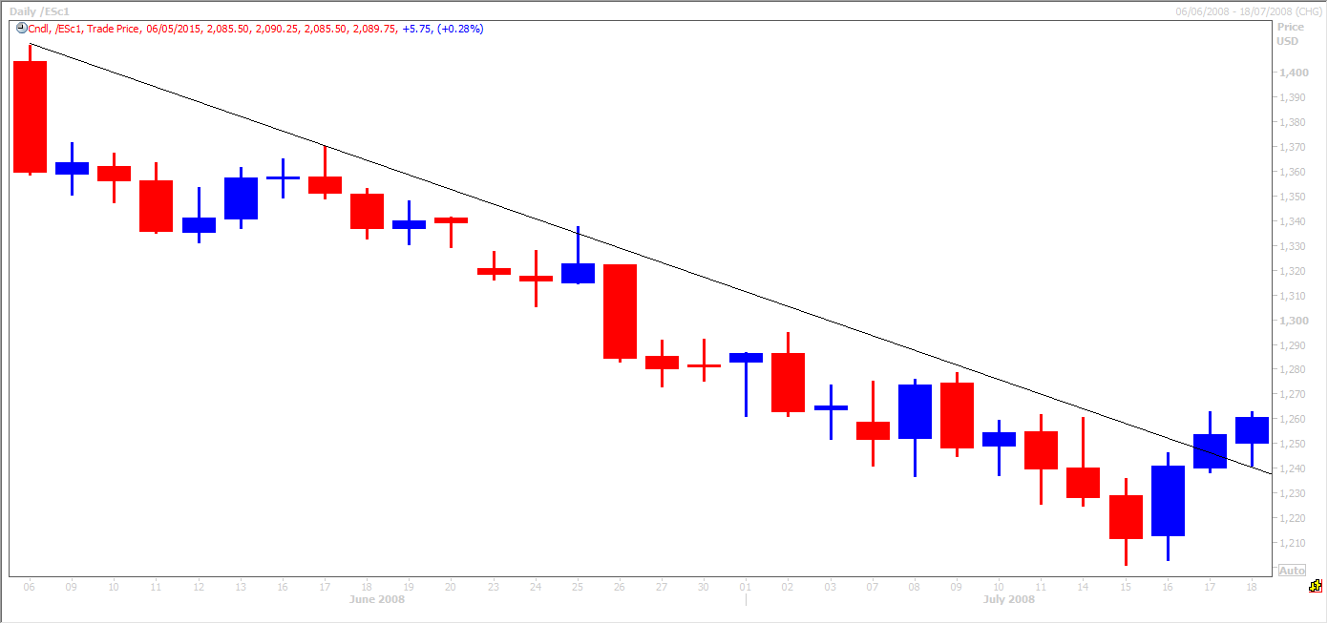
In all of the trend line examples I have provided so far in this course, we can see them working almost perfectly as support and resistance. Whilst perfect trendline examples do occur regularly, this is not always the case. In the example below, correct trend lines have been drawn in red. Significant consecutive high points have been joined up and sometimes the trendline holds perfectly. On other occasions, the price blips above the trendline temporarily, and in fact the trendline acts as a support level until the price settles back below it. (This is one of the key aspects of support and resistance, where a resistance level becomes support when it is broken and a support level becomes resistance when it is broken - more on this in later chapters).
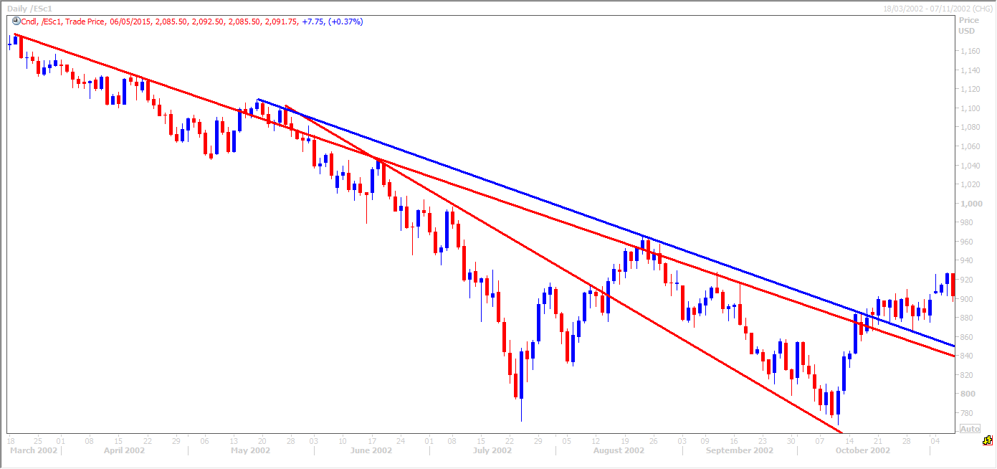
The blue line above is drawn incorrectly as it does not join two significant consecutive price points and is of no particular use in finding profitable trading opportunities.
Downtrend lines act as resistance when the market hits a bout of ‘short covering’ (when traders take profits on their short trades) and indicates that new sellers are prepared to sell at decreasing prices because each successive high is lower than the last.
Trendlines also work well when the market is trending sideways. In the sideways trend below you can see the upper trendline has worked well as a resistance level on several occasions and selling at, or on the approach to this area would have offered several profitable trading opportunities, as the price dipped back towards the lower trendline. Again buying at or just above the lower trendline would have provided several profitable trading opportunities with the price bouncing off here.
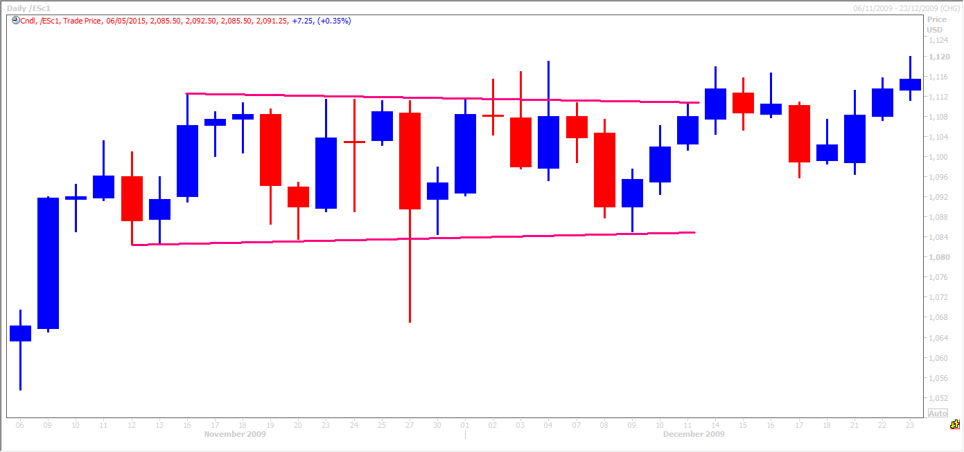
The example above shows clearly how a well established trend line which has held at least 3 or 4 times in the past is only then considered broken if price CLOSES outside of the line. A well established trend line can be tested with a spike above or below as ‘stop-hunters’ try to shake out the weaker traders and force them to stop out of positions, but the price can then recover to close just above the trend line in a bull trend or just below it in a bearish trend line, signalling a false break.

How do I use moving averages to help determine the trend?
Prices rarely move in a straight line within a trend as discussed above, so we can use moving-average lines to help more easily identify the direction of the trend and confirm our trend line analysis.
In the daily chart below the black line represents the 50 day moving average and the green line represents the 100 day moving average. Both have been moving in an upward direction throughout the whole period displayed on this chart. Even when the price has suffered a significant correction or setback, the moving averages have only turned flat and then quickly resumed the upward trend. Following these moving averages would have helped traders to continue to trade the Bull trend and by into support levels. You can see that both the black and the green line have themselves acted as support in many of these corrective phases, within the bull trend.

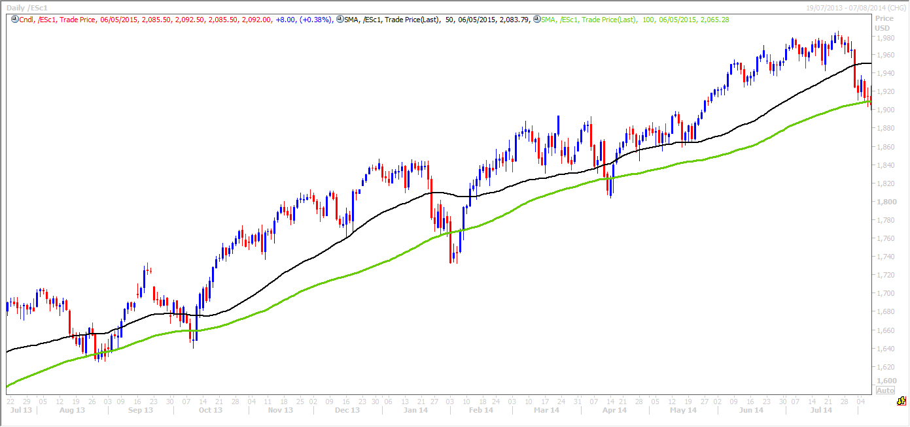
The chart below shows the market in a downtrend and following the moving averages would have given quite a clear indication of the general direction of the longer-term trend. Again you can see both moving averages often acting as their own support, and resistance levels acting as a barrier when the price has moved up, and as a cushion when the price has move down.

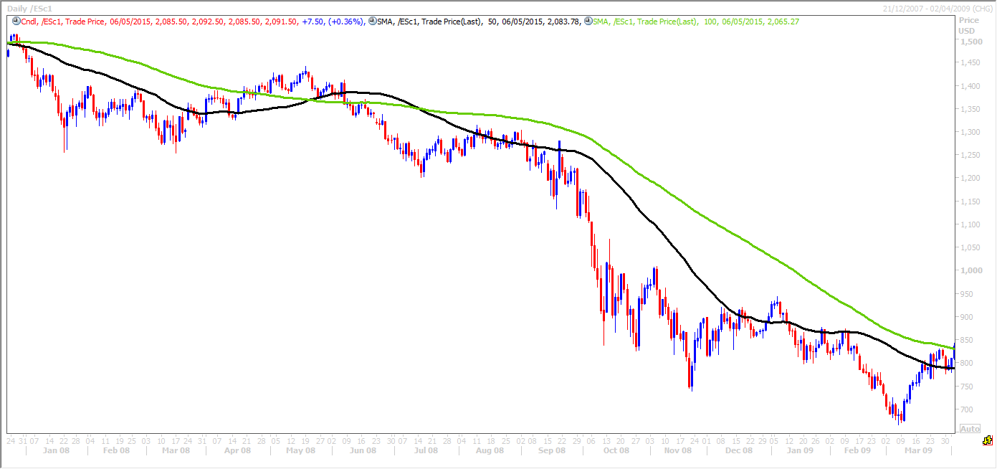
Even when markets trend sideways, such as in the chart examples below, moving averages can help to reinforce that trend. When the price is moving sideways the moving averages also flatten out, crossing below and above each other until finally, the price re-establishes the bull trend and the moving averages turn higher. This scenario is very common within a bull trend where the price has a strong move up and then consolidate in a sustained a sideways pattern until eventually the price breaks higher again to resume the longer term bull trend.
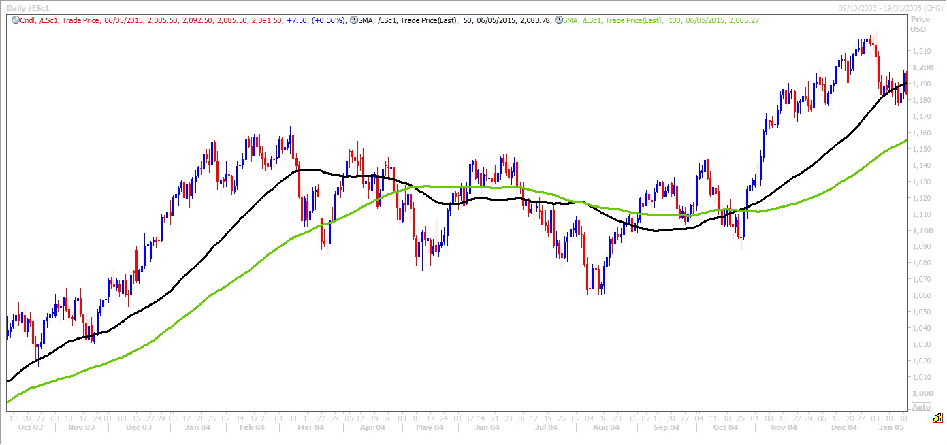
This works in exactly the same way in a negative or bear trend. The price can stabilise after a significant move to the downside and trade within a sideways ‘consolidation’ pattern before eventually re-establishing the negative trend.

How do I figure out what is the prevailing trend for my trading purposes?
Once you feel comfortable in your ability to recognise a trend we have to figure out what is the prevailing trend, according to your trading time frame. For example, a hedge fund trader is likely to be a lot less active than a day trader. When she trades she may take hours or even days to enter a position. She will not be able to enter a large position all at one price and will therefore be scaling in over a wide range of prices and over a longer period of time than a day trader. She will run this position for weeks, months and maybe even years. Therefore she is only interested in longer term trends and as a result is likely to be studying trends over a weekly, monthly or yearly basis.
A day trader is at the other end of the scale and is trading much smaller sums of money. He will be able to enter the market at a single price and may only hold the trade for a matter of hours, minutes or even seconds. Therefore he is not concerned at the yearly, monthly or weekly trend. He is concerned with very short-term trends and therefore the longest time frame he is likely to monitor is the daily chart. He is also likely to be very aware of the hourly trend and perhaps even the 30 minute or 15 minute trend. Some short-term traders even trade the five-minute trend.
The key is to focus on the prevailing trend that is best suited to your trading timeframe. There is no particular rule I offer, it is something specific to each trader which can be perfected through experience, trial and error. Every trader has his or her own particular trading style.
As a guide if you are only interested in taking 5 or 10 pips on a trade and therefore only holding a position for a matter of minutes, it may be advisable to focus on 15, 30 or 60 minute charts. If you only execute two or three trades a day, you may wish to focus on the one hour and daily charts. If you execute a few trades per week, you would most likely be focusing on the daily and weekly charts.
The chart below shows how many short term trends can develop within a longer term bull trend.
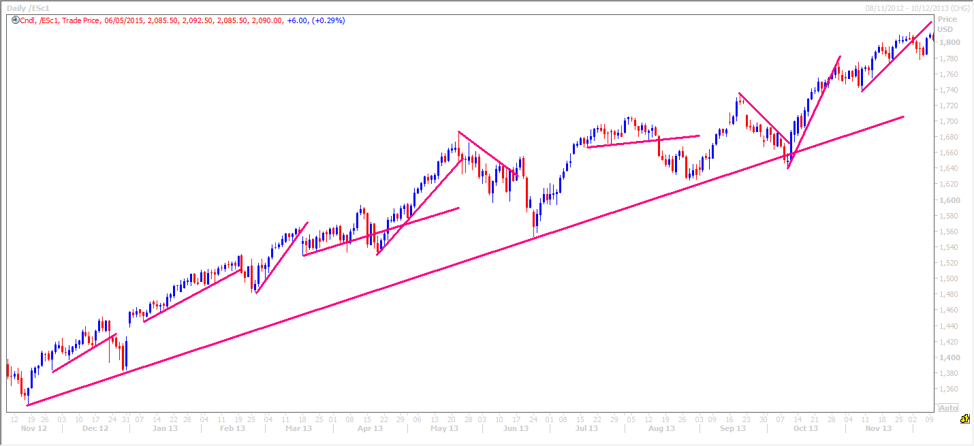
There is one important point to note when studying trends over different time frames.
The technical analysis tools I rely on the most are:
- Trendlines.
- Moving averages.
- Fibonacci retracements and extensions.
All of these tools tend to have a greater effect on the longer term charts. Let me explain. The hedge fund trader we discussed above trades over a longer term period than the day trader. The traders with the power to move markets and change trends for example are the hedge funds, pension funds and investment banks. These market participants trade with vast sums of money and enter or exiting positions with these larger funds has a more significant effect on the market.
As these market participants study the monthly, weekly & daily longer term charts, all traders must at least be aware of the trendline, moving average & Fibonacci points on these charts. It could be an expensive mistake to solely focus on a 1 hour and 15 minute chart as a short term day trader and miss an important longer term support or resistance level, where the larger funds may be entering or exiting their positions. The market could experience a change in the longer term trend at these points.
Make a point of looking at the daily chart every morning, the weekly chart every Monday morning and keep an eye on the monthly chart at least twice per month. Make sure you do not miss an important 4 year long trendline which may be about to trigger significant buy orders over several days!
Why must I always trade in the direction of the prevailing trend?
One of the key golden rules of trading is to trade in the direction of the prevailing trend. One of the first sayings I learned on the trading floor was ‘the trend is your friend’. There is one simple reason why this is very important: Markets tend to remain in a directional trend for sustained periods of time and successful traders know that identifying a trend and entering trade within the direction of that trend is one of the lowest risk trading strategies. Many hedge fund strategies are trend following strategies.
Look again at this typical chart of a bull trend below:

Some interesting Dow Theory points with regards to trend trading.
Dow theory states there are three phases to a primary trend. In a bull market the first is the accumulation or distribution phase. This is the start of a positive trend when informed investors start to buy in to the market. This can often be after a downtrend, which has caused the price of the market to become attractive to these informed investors who see all the bad news as priced into the market. Their fundamental analysis suggests downside risk is therefore limited & the start of this phase can often be quite a steep move higher.
Of course a trend change is far more difficult to spot than an established trend. What may appear to be a levelling out of the market before a reversal of a downtrend may only be a consolidation phase before the next leg lower in a downtrend.
As informed investors begin to buy into the market the market stabilises and can start to enter the public participation phase. During this phase, it starts to become clearer that all the bad news has been priced into the market and price starts to react to positive news. This starts to attract attention from a wider audience of investors and we begin to see higher peaks and higher troughs.

The participation phase tends to be the longest of the three, with the largest price movement. This phase begins to draw the attention of technical and trend traders who spot the early stages of a bull trend, increasing demand and pushing the price higher over a significant time period.
The final phase in the bull trend is the excess phase when investors are buying blindly into the market in the hope that the price continues to drive higher. This is often called the 'greater fool theory' where these investors are hoping to sell to someone who is foolishly prepared to pay an even higher price. Despite clearly excessive valuations they believe that 'this time it is different and the normal rules do not apply'. This is when the 'smart' or professional money is starting to scale back and take profit on their longer term positions.

Key points when drawing trendlines:
- Support trendlines in a bull trend should be drawn from the low of each bar or candle. Resistance trendlines in a bear trend should be drawn from the highs of each bar or candle
- The longer the time frame, the more significant. Longer term levels act as stronger support & stronger resistance levels than short term.
- Trendlines can remain relevant a long time in to the future. You do not want your chart to look like a maze of trendlines but do not be too hasty in removing trendlines as they can surprise you, working over and over again a long way in to the future. I have drawn even more trendlines (in black) in to our example below.
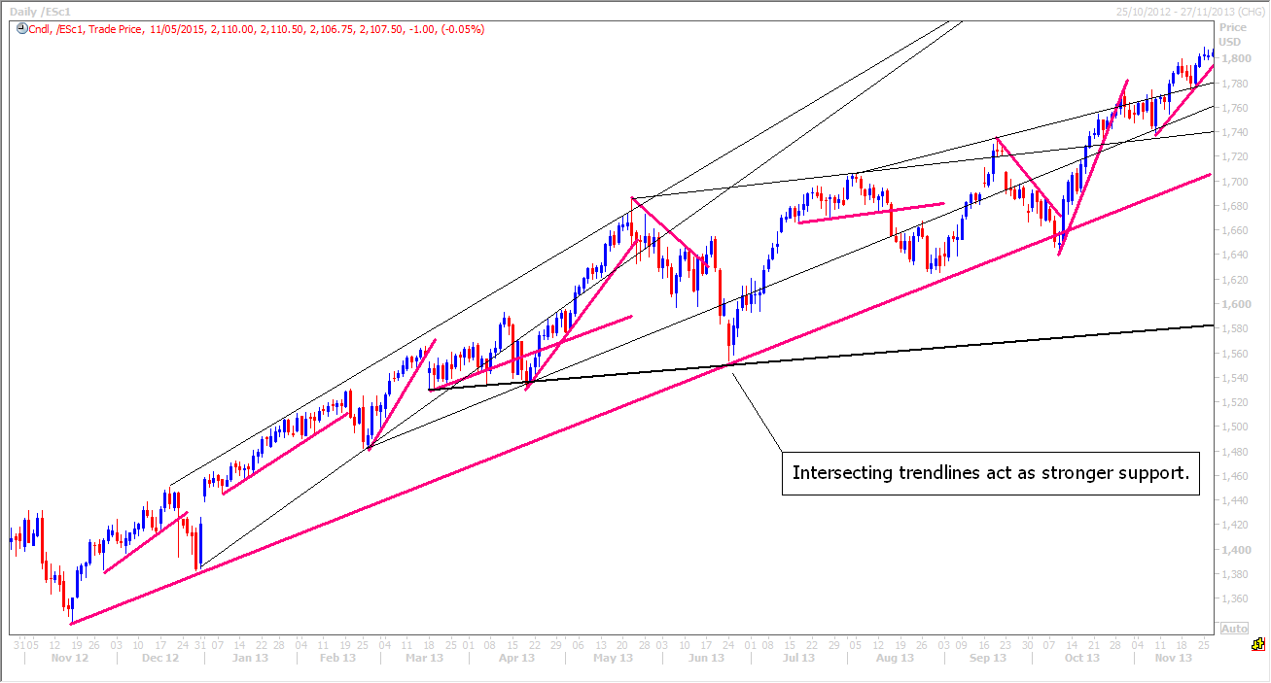
- Trendlines can also be drawn by joining up the highs in a bull trend. These trendlines will act as resistance levels. Although it is not advisable to look for areas to sell in to short positions in a bull trend, these upper resistance trendlines are useful for profit taking areas on long positions which have been entered at support trendlines. See chart above.
- Intersecting trendlines act as stronger support or resistance areas. (See chart above).
- The break of an established trend line is only confirmed with a close outside. This may indicate a change of trend, but not necessarily a reversal in the trend. In a strong bull trend, the break of a trendline may indicate a short term correction. This may lead to a short term trend change from a bull trend to a sideways trend. The market may consolidate to allow overbought conditions to unwind. Once this unwinding of overbought conditions is complete, the longer term bull trend may resume. The old bull trendline however may no longer be relevant and the market may start a new trendline. The skill is recognising this phase and comes with experience. Remember that the break of a bull trend does not indicate the start of a bear trend and vice versa.

There are endless technical analysis tools and when it comes to trendlines which include Gann lines, Gann Box lines, Regression Channel lines, Median Lines, Andrews Pitchfork, Fibonacci Circles, Fibonacci Fans etc. It is all too easy to over analyse, so over my many years of technical analysis of up to 30 markets every day, I have been forced to keep it simple. I have been forced to discard any tool which I personally do not find consistently reliable enough to use on a daily basis. My job is to identify trends & the key support & resistance levels each morning for my bank and fund clients. The key is to keep it simple or you will find support and resistance at almost every price on your chart. The tools & techniques I show you in this course are the ones I use all day, every single day that the financial markets are open. I have studied not all, but most of the tools & techniques. That does not mean other techniques do not work. What does not work for me may well work very well for others. I can only show you what works for me but that does not mean you rule out everything else. I would be narrow minded if I thought I knew all there is to know about technical analysis so you must be open minded and study all the tools and techniques that you can.

Module 3: Candle formations
Candlesticks and Patterns Formed.
Long green or blue candlesticks indicate strong buying pressure. The bigger the body of the candle, the further the close is from the open, showing aggressive buying throughout the period. Such candles are clearly bullish & therefore following a bear trend, they may mark a potential turning point. It is obviously that buyers have made their presence felt!
Long red bodied candlesticks indicate strong selling pressure. The longer the body of a red candle, the further the close is from the open. Sellers aggressively pushed prices lower throughout the trading period. In a bull trend, a long red bodied candlestick can warn of a potential turning point or a high for the current leg of the bull trend.
A Doji is very simple to spot & shows the open and close are at the same price or very near each other (very small body). The length of the shadows or wicks, are not important. It shows that neither bulls nor bears have control of the market, leading to a stale mate. This can sometimes indicate the current trend is becoming tired & a sideways trend could develop or even a reversal in the opposite direction.
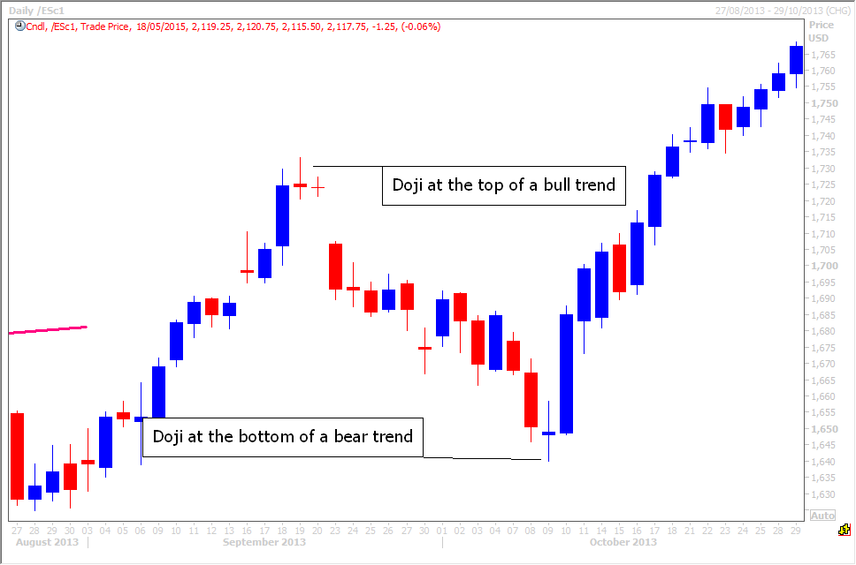

A Gravestone Doji forms when the open and the close occur at the low of the day. In a bullish trend traders want to see as bigger blue bodied candles as possible to reassure them that the bulls remain in control and are managing to push prices higher during the period. The Gravestone Doji is therefore a warning showing that although bulls managed to push prices up during the period, this was unsustainable and bears were able to push the price all the way back down to the opening price. It is a warning that the bulls may be losing control of the market which could lead to either a sideways trend or even a reversal to a more negative trend.
The Gravestone Doji is quite rare but worth remembering....so rare in fact that this was the best example I could find. The open and close are the same & although not at the exact low of the day, close enough to count as a Gravestone Doji!!
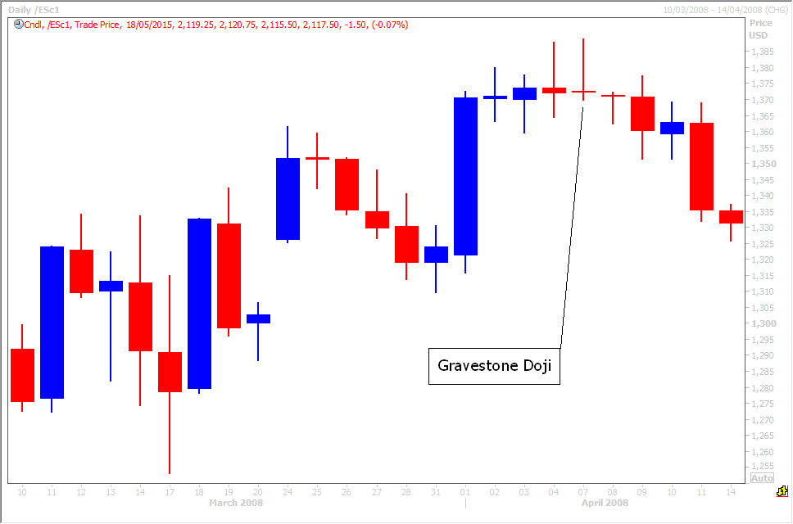

A Shooting Star gives the same warning as a Gravestone Doji. It forms when prices have been in a bull trend and the price heads higher again from the open, showing that bulls remain in control. However, at some stage during the period, price heads lower as bears start to gain control and the close is either just above the open or just below. The resulting candlestick has a long upper wick (or shadow) and a small red or blue body. After a sustained bull trend the ability of the bears to force prices down provides a warning to bulls. To indicate a substantial reversal, the upper shadow should be relatively long and at least twice the length of the body. Bearish confirmation is required after the Shooting Star with a negative candle in the following period. A gap lower on the next candle or long red bodied candlestick on heavy volume would do the trick!
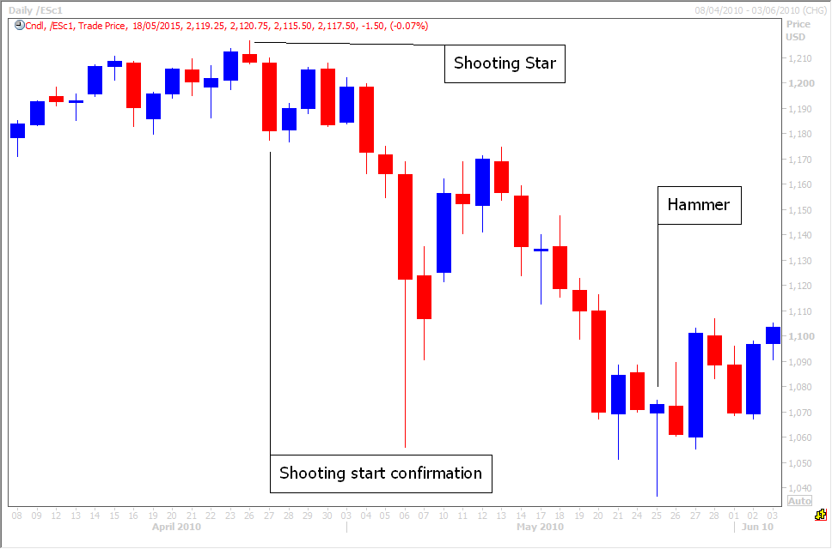
The Hammer and Hanging Man are candlesticks with long lower wicks (or shadows) and small red or blue bodies at the top of the candle. They are therefore the opposite of a Shooting Star. These patterns may indicate the end of a bear trend after a period of lower prices.
The Hammer and Hanging Man candles form when bears continue to have control at the start of the period pushing the price down. However, at some stage the bulls step in and push the price all the way back up to just below or just above the opening price. It shows the bulls are gaining power. A gap higher in the following period or a big blue bodied candle would help to confirm that bulls are gaining control and that the bear trend may have ended.

The Bullish Engulfing pattern consists of two candles – many candlestick patterns require two or more candle – and indicates the end of a bear trend. The first is a red candle showing a lower close for the day. The sellers are still in control of the market in a bear trend. On a bar chart it is often called a key reversal.
This is one of my favourites and I do not ignore this pattern when I see it – it often warns of the end of a bear trend. The next candle to form has a large blue body & is formed as the price opens lower than the previous day...initially keeping bears happy!! However the bulls seize control & push the price higher so that the close is above the previous day’s open. This candle ‘engulfs’ the previous day's body, showing overwhelming buying pressure and indicating that bulls may be starting to gain control of this market.
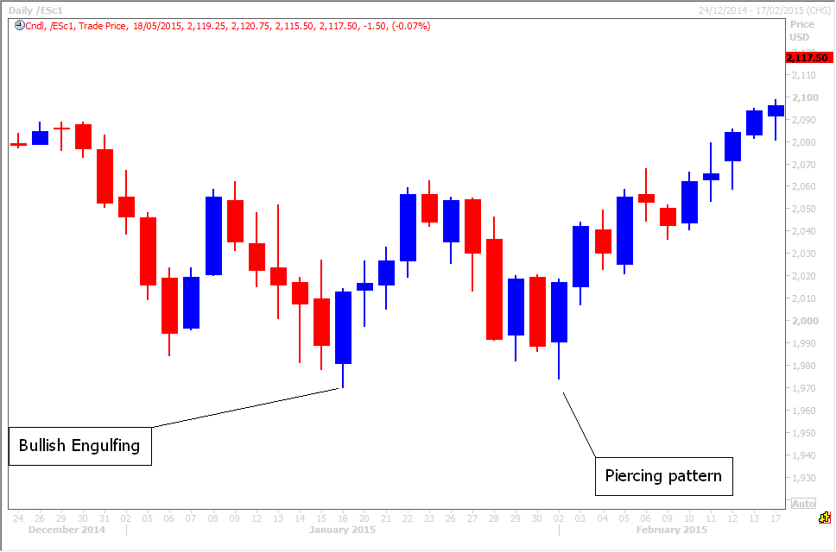
The Bearish Engulfing pattern is the opposite of the bullish pattern & again, I do not ignore this pattern when I see it! Initially the market heads higher to make a new high for the bull trend. However bears then seize control & force prices lower in to the close. The red body of the second candle completely engulfs the previous day's blue body. This shows that the bears are potentially gaining control of the market.
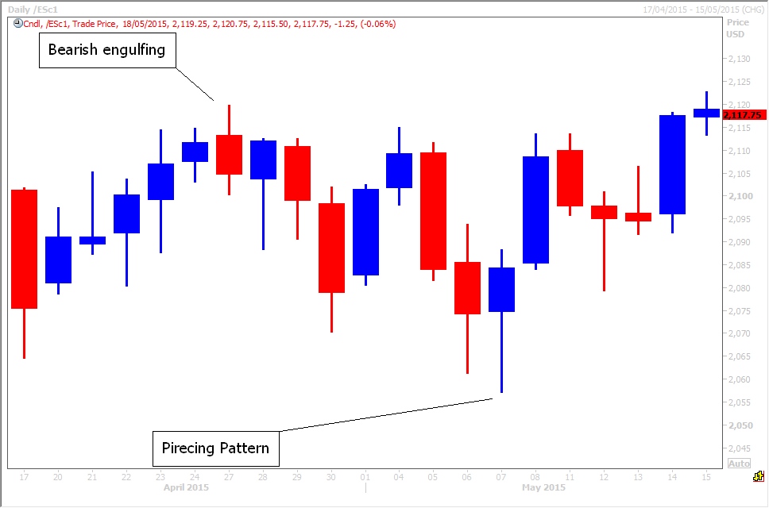

The Piercing pattern is the opposite of the Dark Cloud Cover and after a period of the market trending lower, this can indicate that bears are losing control. Therefore the market might start to trend sideways or even reverse the bear trend and start developing a bull trend.
The first day of the pattern has a red body as bears push lower in the negative trend. The next day the market heads lower initially (and may open below the previous day's trading close), keeping bears confident. However after a new low has been reached, bulls seize control during the period & push the price higher, to close above the half way area of the previous day’s candle.
Dark Cloud Cover is the opposite of the Piercing Pattern. It is another two candle pattern. This bearish pattern is often found at the end of bull trend. The potential reversal signal is not as strong as an engulfing pattern but I do always pay attention to it.
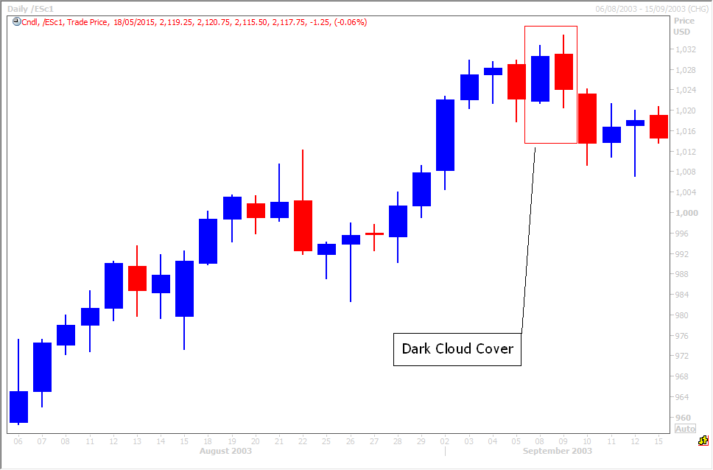
The first day of the pattern has a blue body as bulls push higher in the positive trend. The next day the market pushes higher to make a new high (it may open above the previous day's trading close), making bulls feel confident, as in the engulfing pattern above. However bears seize control & push the price down to close below the half way area of the previous day’s candle.
The Morning Star consists of three candles & signals the potential end of a bear trend & reversal to a bull trend. It is quite a reliable signal so worth remembering.
The first large red candlestick is normal in a bear trend so this does not give any alert to traders. The second candle is small-bodied (either red or blue) that often gaps open below the close or even below the low of the first red candle. The close is also below the first red candle.
The last candle completes the pattern providing the alert & potential reversal signal. This is a large blue bodied candle that gaps open above the second candle and closes near or above the middle of the first red candle's body.
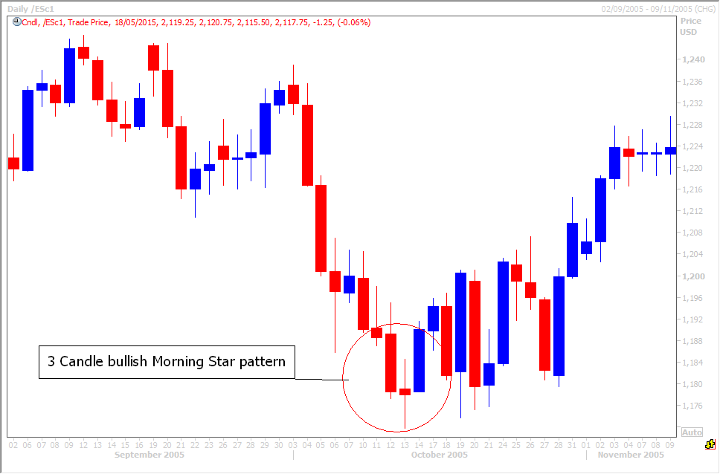
The Evening Star is the exact opposite of the morning star & is a warning that the bull trend is ending or reversing. Again, it is quite a reliable signal so worth remembering.
The first large blue candlestick is normal in a bull trend so this does not give any alert to traders. The second candle is small-bodied (either red or blue) that often gaps open above the close or even above the high of the first blue candle. The close is also above the first blue candle.
The last candle completes the pattern providing the alert & potential reversal signal. This is a large red bodied candle that gaps open below the second candle and closes near or below the middle of the first blue candle's body.
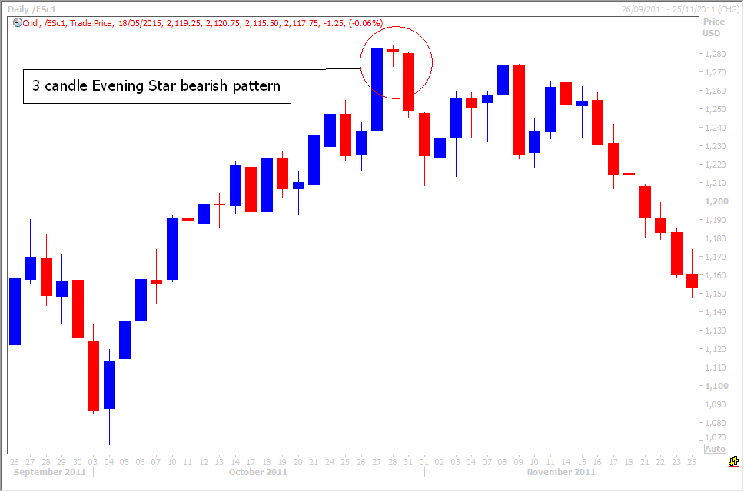
A Bullish Harami pattern consists of a large bodied candle in a bear trend, that closes near the bottom of the price action for the period, clearly indicating sellers are still in control of this market. However on the second day, a small blue bodied candle forms, holding within the previous day’s body. This indicates the bears may be losing control.
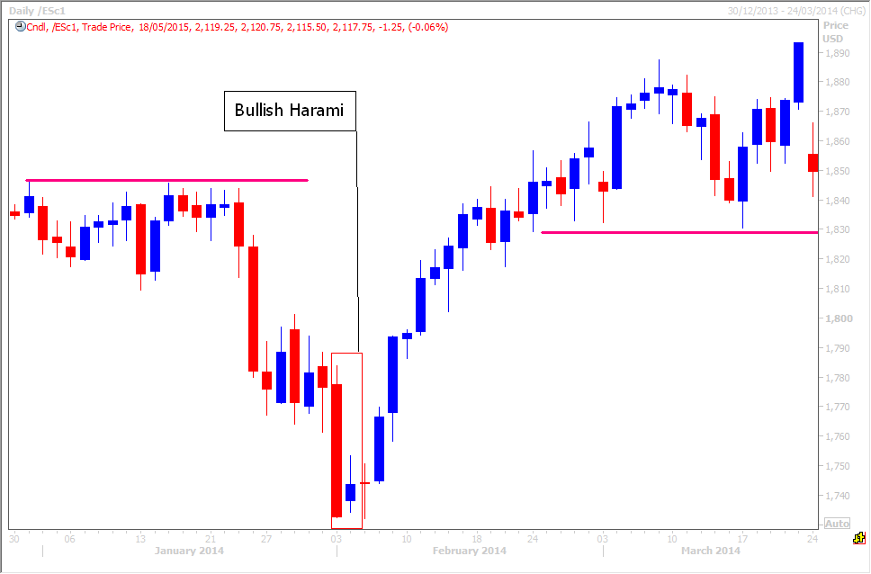
A bearish Harami pattern consists of a large blue bodied candle in a bull trend, that closes near the high of the price action for the period, clearly indicating buyers are still in control of the market. However on the second day, a small red bodied candle forms, holding within the previous day’s body. This indicates the bulls may be losing control.
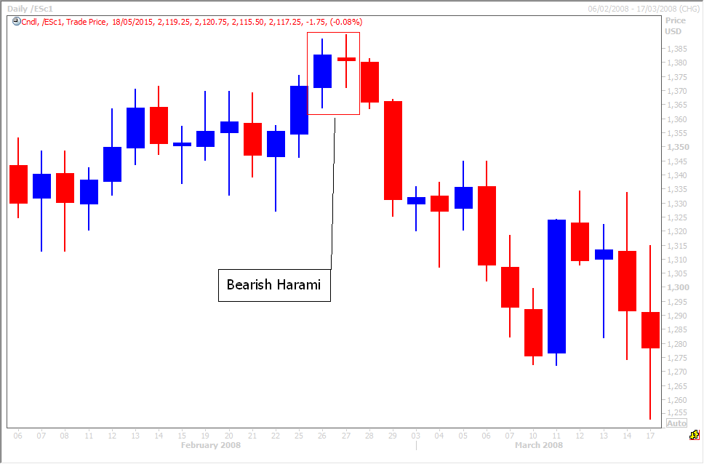
I just want to add 3 notes here:
  - There are dozens of candlestick patterns one can learn. If I am being honest I have read many books and seen all the patterns but I do not remember them all. The purpose of this course is to show you what I find works for me in my daily technical analysis of over 20 markets. The patterns above are common enough & effective enough to be worth memorising but having said that, THEY DO NOT WORK EVERY TIME. Technical analysis is an art not a science. Nothing is fool proof, nothing is guaranteed. Like almost everything in life, you can learn all the theory but only experience will help you to effectively make profits in the longer term from technical analysis.
What I want to do in this course is save you time. I want to show you what has worked consistently over many years for me. I hope this will save you a huge amount of time studying areas of technical analysis which may not help you on your quest for day trading profits.
  - The images of examples of each pattern having been taken from the Emini S&P chart. You can Google these patterns & find perfect text book examples but I want to show you that in real life it is hard to find perfect examples. You have to use some ‘interpretation’. It may not be a text book pattern but if it looks pretty close to the pattern then it may well work like the pattern.
  - The other reason I used real chart examples of the patterns is to show you that just because the pattern forms does not mean the market will move in the anticipated direction immediately...the market may pause as bulls and bears battle it out before the expected move occurs.
Patience in trading & using appropriate stop losses in case the pattern does not play out is imperative. More on these important issues later!
Module 4: Moving Averages as basic Indicators
Use of Various Types of Indicators to Generate Buy/Sell Calls - Understanding the various indicators and using them effectively for generation of buy and sell signals.
What are Moving Averages?
We have already touched on moving averages as a tool in trend identification. Now let’s examine in more detail.
Moving averages smooth price data to help identify the current trend. However it is important to remember that moving averages are a lagging indicator, as they are based on historical prices. We use them because trends do not move smoothly in one direction...price tends to chop around in the short term but will follow a trend in the longer term. Moving averages help to smooth the price action over time and therefore help to more clearly identify the longer term trend. Many other technical indicators such as MACD and Bollinger Bands use moving averages as the basis of their makeup.
The two most popular types of moving averages are the Simple Moving Average (SMA) and the Exponential Moving Average (EMA) but other examples you may hear about are: adaptive, centered, volume adjusted, weighted etc. I only follow the simple moving average but will examine the two most popular, to help you decide which may work for you.

The two most common calculations of moving averages.

Simple Moving Averages
A simple moving average is calculated by taking a period of closing prices & adding them together then dividing them by the number of closing prices you have. So a 10 day MA takes the last 10 days closing prices. Add them up and divide by 10. You now have the first value for your 10 day moving average. The next day you add the new closing value, deduct the first closing value from the day before and again, divide by 10. Simple!
A 10 day moving average will therefore change more dramatically than a 100 day moving average. Both are lagging indicators but the longer term moving averages react much more slowly to price change.
Exponential Moving Averages
Exponential moving averages differ because they apply more weight to the more recent prices in the calculation. The idea is to make this moving average more sensitive to recent price changes. Exponential moving averages will turn before simple moving averages when prices changes direction.
I stated above that I only use simple moving averages. Why? To me they represent a true average of prices for the entire time period so I believe they are better suited to identify support and resistance levels. I primarily use the value of the moving average as a support or resistance level. I also focus on the 55, 100 & 200 period moving averages as I believe they offer the most reliable levels – whether that period be a monthly, weekly, daily or hourly chart.
However bear in mind that I do need a ‘one –size-fits-all’ approach to my technical analysis. This is because I provide daily technical analysis to professional traders on up to 25 markets each morning. I do not have the time to perfectly fit each moving average for each time period for each market. If you only trade one or two markets, it could be worth experimenting with different time periods to see if you can find ones that better suit those markets and therefore provide more reliable support & resistance levels.
Lengths and Timeframes.
The length of the moving average that you should follow depends on your trading style. A day trader looking at a daily chart is likely to be more focused on short term moving averages eg. 5-25 day. Long-term traders/ investors, such as the hedge and pension fund managers mentioned previously, will prefer longer term moving averages such as 100 & 200 day moving averages.
It is again important to note that even a short term trader must therefore be aware of these longer term day moving averages. If the traders who are moving large sums of money are focused on the 100& 200 day moving averages, then you must be aware of where these values are. An hourly chart may be telling you that there is an excellent shorting opportunity at current prices, but if we are just approaching the 100 day moving average support then the longer term chart would be more important to follow. Selling in to major longer term support, where large funds could be buying would clearly not be advisable!
This is why I focus on the 55, 100 & 200 period moving averages - but I use these periods on my short term (eg. 1 hour) charts also. Try using the 55, 100 & 200 hour moving averages as support & resistance levels on your hourly chart. I find these to be reliable trading levels, when combined with other technical analysis tools.
The chart below shows a 55 day moving average (purple line) working quite effectively as support in the left half of the chart. When the moving average is broken on the right hand side of the chart, you can see how it initially works as resistance until price makes a break back above the moving average.
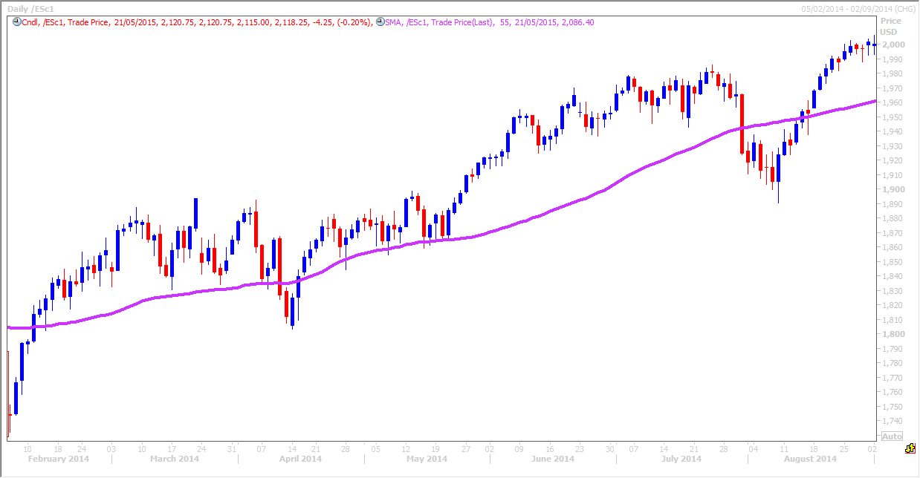
Note: This is one of the keys to successful technical analysis trading – finding areas of support & resistance from several different tools that over-lap. Not only on one time period, but across different time periods. Remember, we look to buy at support in a bull trend but sell at resistance in a bear trend.
I study up to 5 time periods for each market & apply my technical analysis techniques to all time periods. It is only when I have completed the analysis for all time periods that I can clearly identify the important levels for trading. To repeat! – the longer term levels are always more important than the short term levels & we know why. However when the longer term & short term levels all line up together, this provides very powerful trading opportunities.

Using moving averages for trend Identification
A rising moving average shows that prices are generally increasing & a falling moving average indicates that prices are moving in a bear trend over the moving average period. A rising 25 day moving average indicates a short term uptrend. A falling long-term 200 day moving indicates a long-term downtrend.
When combined with your trend line analysis the moving averages not only help to identify the prevailing trend but also provide support & resistance levels. When a moving average support coincides with a trend line support (in a bull trend), the support level is seen to have added strength & therefore gives the trader more confidence in buying.
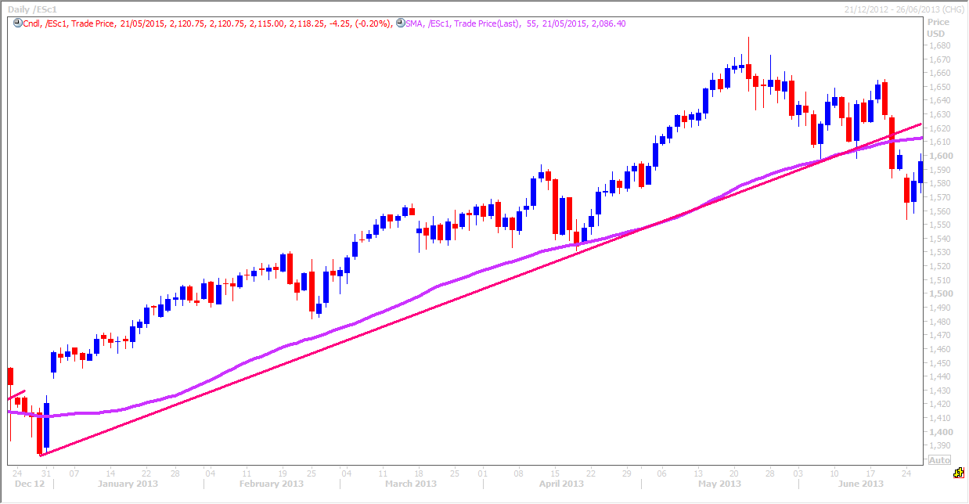
In the bull trend above you can see the red trend line providing support on at least 3 occasions. The purple 55 day moving average is also heading in an upward direction, in fact at almost the same angle as the moving average. The moving average gives the trader added confidence in buying at trend line support because this is also moving average support.
Technical analysis traders like buying when support levels are reinforced with other indicators.
Remember a moving average support level is only considered broken if price CLOSES outside the line. A spike through the support or resistance is common, as ‘stop-hunters’ try to shake out the weaker traders and force them to stop out of positions, but the price can then recover to close just back inside the moving average. This signals a false break and that the trend remains intact.
Module 5: Indicators & oscillators measure trends & provide trade signals.
Indicators are calculations based on the price and/or volume to measure trends, volatility and momentum. Indicators are based on price movements and are therefore an additional tool to price analysis. Indicators confirm price movement or trend and the quality of chart patterns but also provide their own buy and sell signals.
Indicators are either leading or lagging. A leading indicator precedes price movements, giving them a predictive quality, while a lagging indicator such as the moving average example above is a confirmation tool because it follows price movement.
Oscillators tend to trade in ranges from 0 to 100 but both lagging and leading indicators provide buy and sell signals mainly through crossovers and less so through divergence with the price. A price cross over through a moving average provides a signal but also two different moving averages crossing over each other provide a second signal.
When price is trending in a different direction to an indicator (eg stochastic, RSI or MACD), this divergence indicates the direction of the price trend is weakening.
Indicators are best used in conjunction with price movement, chart patterns and other indicators to build up a complete picture of what is happening in the market to determine future direction and low risk trading opportunities.

Moving averages provide buy and sell signals.

Moving average price crossovers
So far we have seen how moving averages can be very useful in identifying trends over different time periods and also how the values of the moving averages work as support & resistance levels. Now we will see how the moving averages themselves provide buy & sell signals.
A moving average ‘cross over’ is used as a trade signal. This is one of the main reasons for using more than one moving average. The longer moving average is used to identify the longer term trend and the shorter moving average is used to generate the signals.
1. A bullish signal is first generated when prices move above the moving average. The example below shows the bottoming out of the Emini S&P after the 2008 financial crisis. Were there any clear buy signals to tell us the market had bottomed?
- The first signal was generated when the price of the Emini S&P crossed over above the 55 day moving average (purple line) which was already flattening out, indicating that the bear trend may be ending.
- Confirmation of this buy signal was generated when price crossed above the 100 day moving average (black line), which was also flattening out, indicating that the longer term bear trend may be ending.
- .The market is now clearly in a short term bull trend. If you had begun buying on the first price cross over and added to your investment on the second cross over you would be looking at healthy profits going forward.
As long as price holds above the moving averages, the investor is feeling confident. You can see that it did not take too long for the moving averages to confirm the positive trend as they started to turn upwards. Even after such a dramatic crash in 2008, both moving averages had turned higher within 2-3 months of a bottom being established.
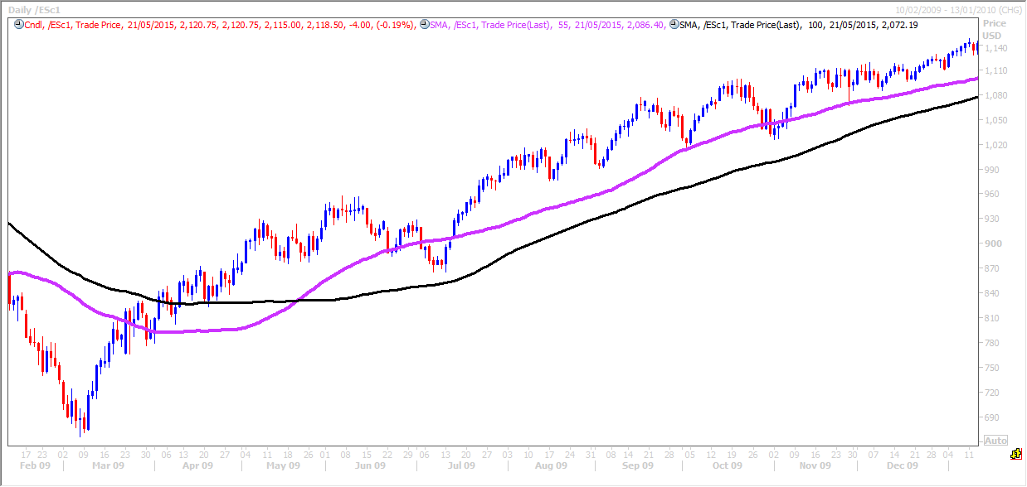
- Another bullish signal is generated when the faster 55 day moving average crosses and holds above the slower 100 day moving average. This is further confirmation that a bullish trend is being established. This is called a ‘Golden Cross’ when a fast moving average crosses above a slow moving average. Ideally both moving averages should be at least starting to turn higher as they cross for the best signal.
You can see how the 55 day moving average did a good job most of the time, in providing support when the market hit some short term profit taking. When this level failed however the 100 day moving average worked as the next support, confirming that the market remains in a positive trend. The price crossing below the 55 day moving average was not a negative signal because the moving averages are clearly pointing higher and the price never broke the 100 day moving average support area.
2. A bearish signal is generated when prices move below the moving average.
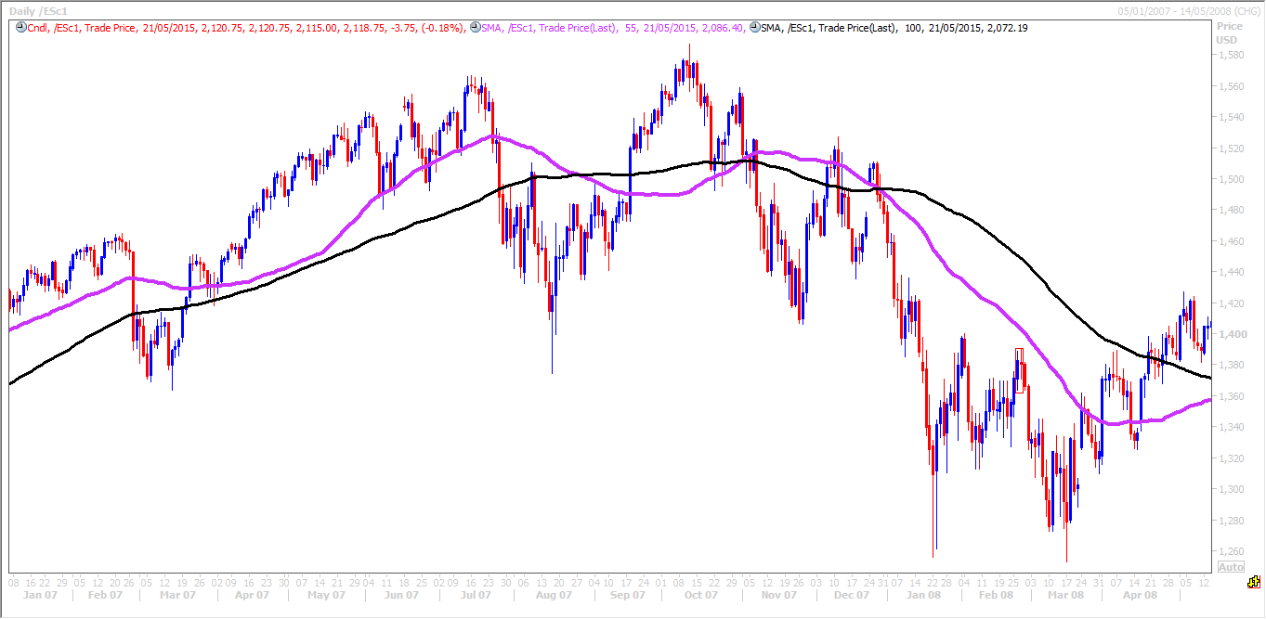
This chart above shows the Emini S&P topping after a four and a half year bull market run from 2003 to 2007. Initially the market enters a sideways but very volatile trend. Note that bull markets tend to end with very volatile conditions such as the example here as bulls & bears battle it out for control. Bear markets tend to end much more quickly with a ‘V’ shaped turn in the market.
The moving averages and also the price cross above and below for a period of time to indicate the sideways trend. Eventually the 55 day moving average and the price holds below the 100 day moving average and at that stage the market collapses and in fact crashed very sharply.
This was only the beginning. There was some confusion about half way through the crash as the price made a break above the moving averages & the 55 day moving average crossed back above the 100 day moving average.
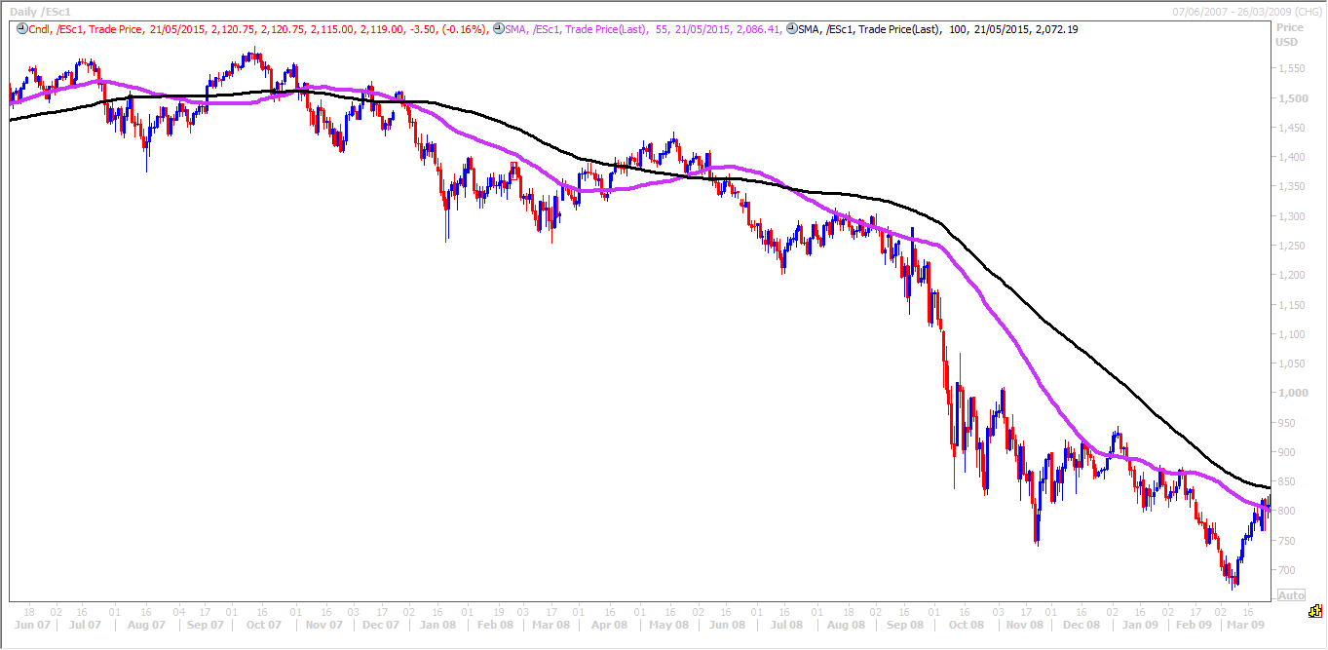
However the 100 day moving average continued to point lower throughout this period. It was not long before price collapsed again & held below both moving averages in a negative signal. This was confirmed with the 55 day moving average crossing back below the 100 day moving average. The 55 day moving average continued to do it’s job well as a strong resistance level on any bounce and the market crashed again. The moving averages continued to point lower throughout this crash to confirm the bear trend.
When a fast moving average crosses & holds below a slow moving average this is called a ‘Dead Cross’. Again, like the ‘Golden Cross’, it is a stronger signal when both moving averages are starting to point lower when they cross.
3. A triple crossover involves three moving averages as you may have guessed. Again, a signal is generated when the shortest moving average crosses the two longer moving averages. I imagine there is no end to the number of moving average crossovers you could employ but 2 should be enough!
Important points to note when using moving average cross over signals.
Moving average crossovers produce late signals because they are lagging indicators. The longer the moving average periods, the greater the lag in the signals. A moving average crossover system will therefore produce lots of whipsaws in the absence of a strong trend. This is clearly demonstrated with the last example above when the four and a half year bull trend ends at the time of the financial crisis in 2008. The moving averages whipsawed until finally the bear trend became established.
For this reason I do not pay must attention to 100 & 200 moving average crossovers, I only watch the 55 & 100. Often by the time the longer term lagging indicators cross, the move has actually ended!
You may wish to experiment with short term moving averages on the markets you trade to see if you can find reliable cross over time periods to follow.
Stochastic Oscillator
The Stochastic Oscillator is a momentum indicator that compares the closing price to the price range over a given time period. In other words it shows the close relative to the range over a set number of periods. In a bull trend prices should tend to close near the upper end of the range. In a bear trend, prices tend to close near the low of the range. Therefore the Stochastic Oscillator is designed to follow the speed or momentum of the market.
The stochastic oscillator contains two lines. The first line is the %K, which is essentially the raw measure used to formulate the idea of momentum behind the oscillator. The second line is the %D, which is simply a moving average of the %K. The %D line is considered to be the more important of the two lines as it is seen to produce better signals. The stochastic oscillator generally uses the past 14 trading periods in its calculation.
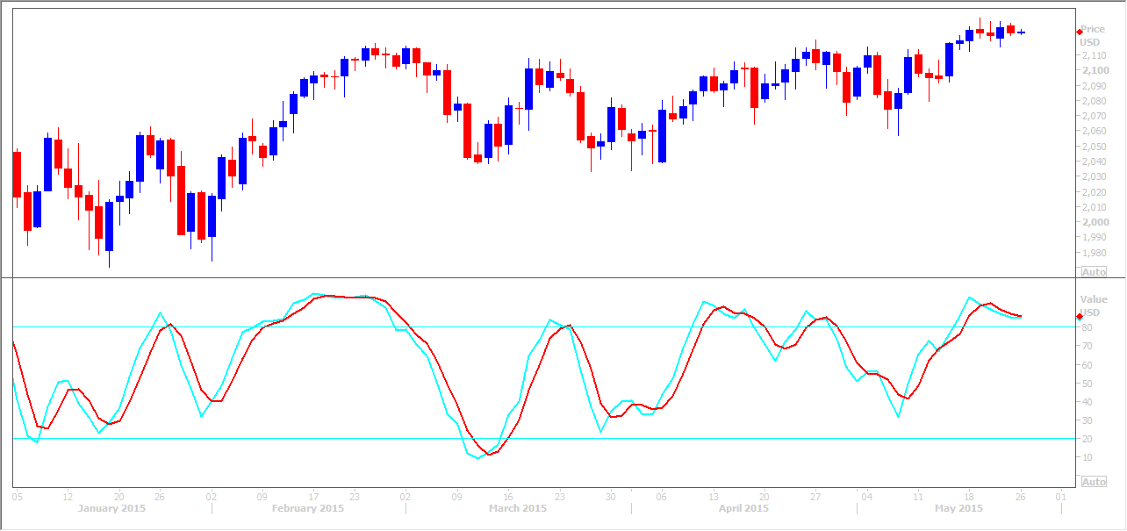
As a rule, momentum changes direction before the trend, therefore divergences in the Stochastic Oscillator can be used to indicate potential reversals in trends. It the Stochastic Oscillator is starting to turn lower in a bull trend or is having lower highs when price is showing higher highs, this indicates that momentum is changing. Price is failing to close in the upper area of the range despite the continuation of the bull trend.
This is my favourite indicator and I also find it useful for identifying overbought and oversold levels. Note: I only follow the slow Stochastic Oscillator.
The Stochastic Oscillator is above 50 when the close is in the upper half of the range and below 50 when the close is in the lower half. Low readings (below 20) indicate that price is near its low for the given time period. High readings (above 80) indicate that price is near its high for the given time period.

The stochastic as an overbought & oversold indicator.
The oscillator ranges from 0 to 100, making it easy to identify overbought and oversold levels. No matter how fast or how far a market moves, the Stochastic Oscillator will always fluctuate within this range. Traditional settings use 80 as the overbought threshold and 20 as the oversold threshold. Readings above 80 for the 20-day Stochastic Oscillator would indicate that the underlying security was trading near the top of its 20-day high-low range. Readings below 20 occur when a security is trading at the low end of its high-low range.
It is important to note that oversold readings are not necessarily bullish and markets will remain oversold for long periods of time in a bear trend. Closing levels consistently near the bottom of the range indicate sustained selling pressure. Watch for big red bodied candles!
Overbought readings are not necessarily bearish. A market can and will remain overbought for very long periods of time in a bull trend. Closing levels that are consistently near the top of the range indicate sustained buying pressure. Watch for big blue bodied candles!
In the chart below you can clearly see the strong bull trend indicated by a red trend line, to the right of the chart. The stochastic becomes overbought at an early stage of the rally & remains severely overbought. A trader selling in to shorts in this bull trend would potentially wipe out his account and many traders have made this mistake!
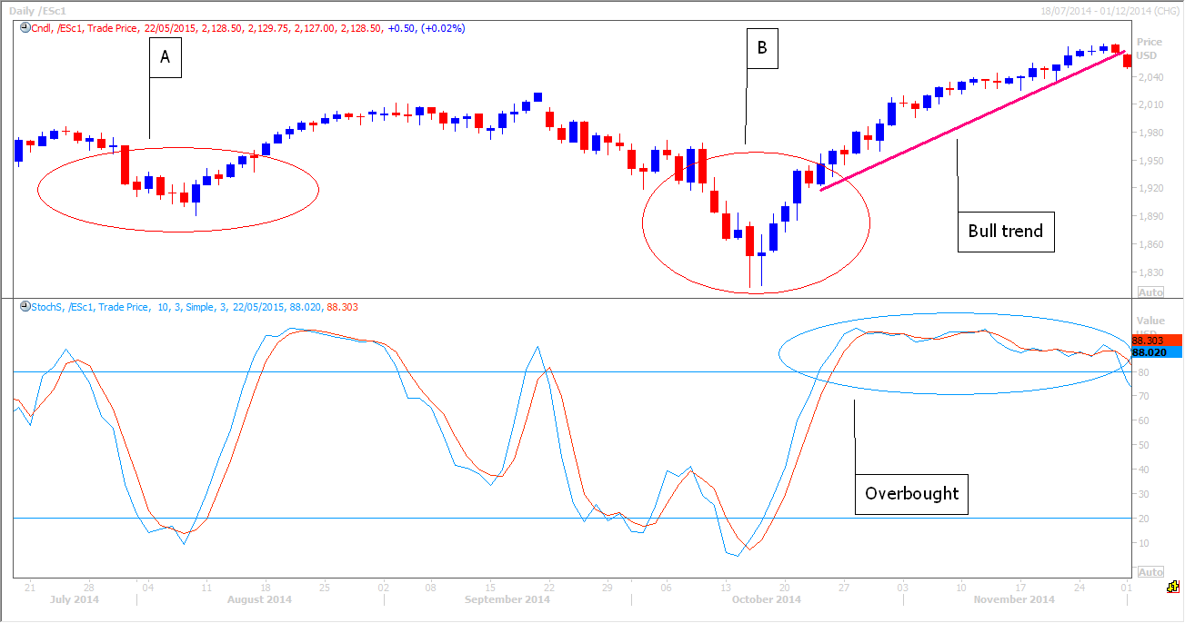
Therefore the Stochastic Oscillator must only be used as a potential buy signal (when combined with other technical analysis tools) in a bull trend or a sideways trending market.
See point A and B in the chart example above.
If the market experiences a negative short term correction in a longer term bull trend and becomes oversold on the Stochastic Oscillator, this could present an opportunity to buy back in to longs. Ideally a trader will be looking for suitable support levels to enter this trade, rather than just buy blindly. A bounce from oversold conditions in a bull trend can often be very steep offering quick profits.
Note that when the stochastic crosses back above the blue 20 line in the example above, this acts as confirmation of a potential move higher. Some traders would use this as a buy signal, confident that the bull trend has resumed.
The Stochastic Oscillator must only be used as a potential sell signal (when combined with other technical analysis tools) in a bear trend or a sideways trending market. If a market experiences a bullish correction in a longer term bear trend and becomes overbought on the Stochastic Oscillator, this could present an opportunity to sell short. Ideally a trader will be looking for suitable resistance levels to enter this trade. Or in a reverse of the bullish example above, a cross below the 80 line could be used as the sell signal, indicating that the bear trend has resumed.

Bull & Bear Divergences
A negative or bearish divergence forms when a new high in a bull trend is not confirmed with a new high in the Stochastic Oscillator. This shows decreasing upward momentum in the trend & could indicate a potential reversal. In other words, a bearish divergence forms when price hits a higher high, but the Stochastic Oscillator forms a lower high.
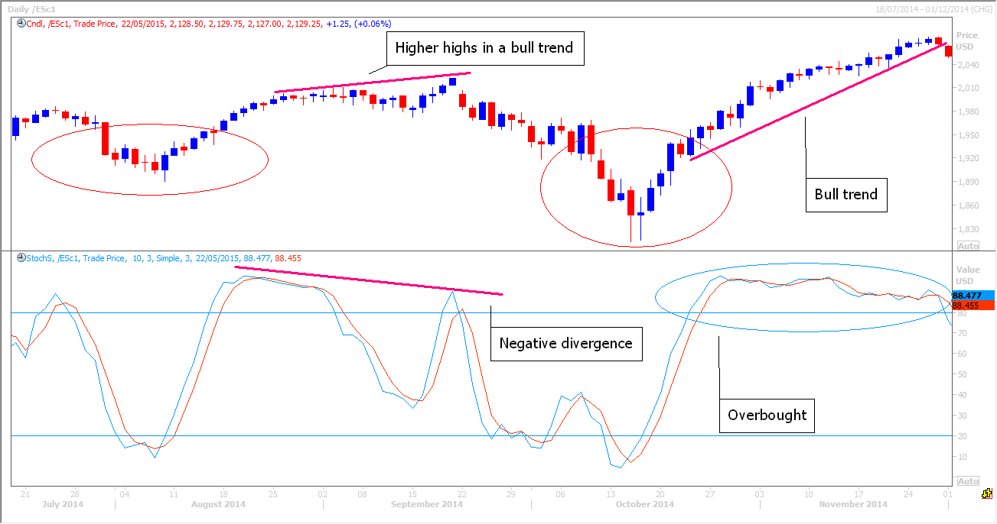
For timing purposes we would look for a bearish confirmation, such as a break below an upward sloping trend line coupled with the stochastic crossing below the 80 line, before entering a short trade. Just as a market can remain overbought for long periods of time, several bearish divergences can form & timing a sell off on the bearish divergence alone is too risky. Wait for confirmation from candle formations and other technical analysis tools! See example below.
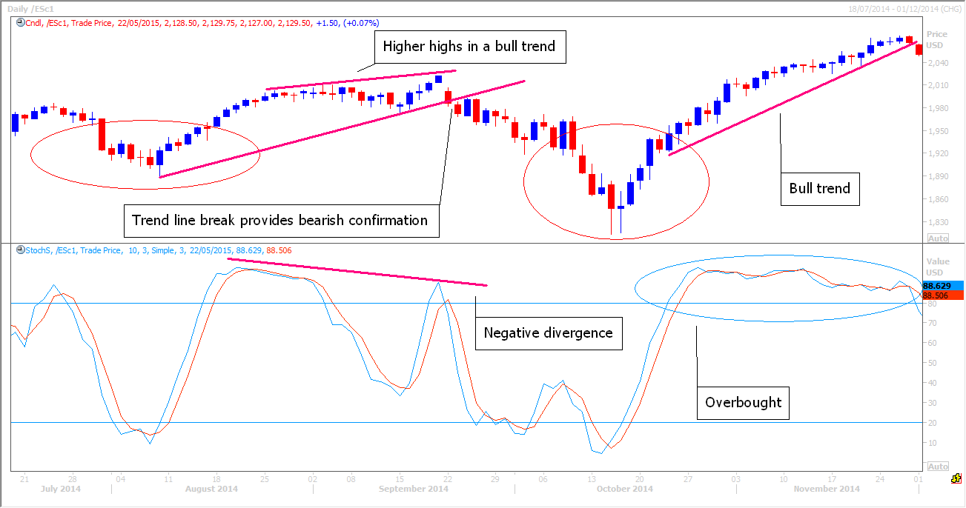
A bullish divergence forms when price records a lower low, but the Stochastic Oscillator forms a higher low. This shows less downside momentum that could indicate a potential bullish reversal.
The half way point or 50 level on the Stochastic Oscillator is also worth watching. A Stochastic Oscillator cross above 50 signals that prices are trading in the upper half of their range for the given period and is an added positive signal or confirmation of a continued move higher.
A cross below 50 means prices are trading in the bottom half of the period and suggests an added negative signal or confirmation of a continued move lower. In fact the half way mark can act as a support or resistance area. This is not the strongest of signals but just keep an eye on it for confirmation of the trend!
Like all technical indicators, it is important to use the Stochastic Oscillator in conjunction with other technical analysis tools. Volume, support/resistance and breakouts can be used to confirm or refute signals produced by the Stochastic Oscillator.
Using the stochastic to generate trade signals.
So you should be familiar with how the Stochastic Oscillator is used to identify the momentum of a trend & how it can be used as an overbought or oversold indicator. We have seen how once a divergence is spotted we can use confirmation in price to generate a tradable signal.
Crossovers are commonly used to identify other buy and sell signals. In the chart example below see how signals are generated when the fast blue line crosses below the slow red line, when prices are overbought. A break below the 80 line helps to confirm the negative signal or can in itself be used to trigger a sell signal.
Watch out for false signals – remember selling short in a bull trend is high risk & therefore we are likely to get false signals.
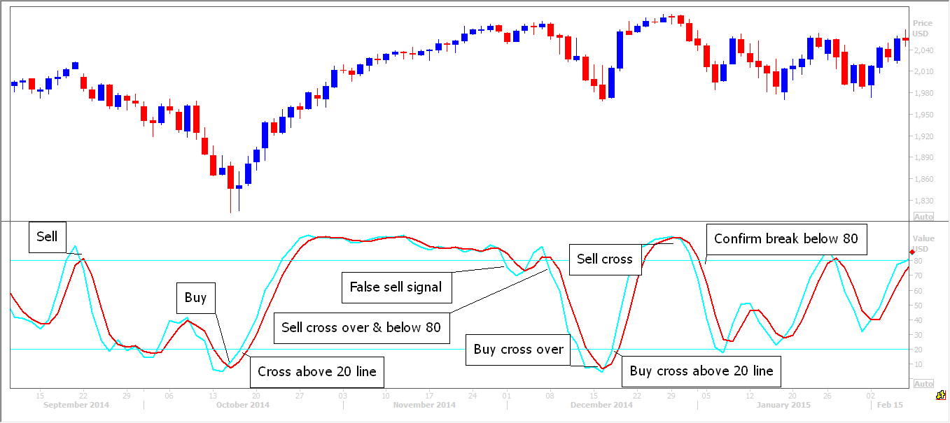
A bullish crossover of the fast blue line above the slow red line, when price is oversold triggers a buy signal. This is a low risk buy signal as the market is in a longer term bull trend. A cross of both lines back above the 20 line is an added buy signal. Remember to use these signals with your other technical analysis tools to build a picture of what is happening with price and when to trade it in the direction of the prevailing trend.
Bollinger bands
I will not go in to too much detail on Bollinger Bands because although I have used them in the past, I no longer find them particularly helpful. However it is worth being aware of what they are and how they work.
Bollinger Bands are volatility bands shown above and below a moving average (usually 20 period) and are based on standard deviation which changes as volatility increases and decreases. The outer bands are usually set 2 standard deviations above and below the middle band and automatically widen as volatility increases, then narrow as volatility decreases.

A move originating after the rejection of one band often tends to go all the way to the other band.
Bollinger BandWidth is an indicator derived from Bollinger Bands & measures the percentage difference between the upper band and the lower band. Therefore BandWidth decreases as Bollinger Bands narrow and increases as Bollinger Bands widen.
A Bollinger BandWidth Squeeze provides a signal to traders and occurs when narrowing bands show volatility has fallen to a low level. Periods of low volatility are often followed by periods of high volatility. Therefore narrow BandWidth can occur before a significant advance or decline. After a Squeeze, a price surge and band break signal the start of a new move. So to summarise, a significant move tend to happen when the bands contract and tighten towards the average and the longer the period of less volatility, the higher the propensity for a breakout of the bands.
As with most indicators, then general rule is that when there is a breakout of the band, the current trend is usually maintained.
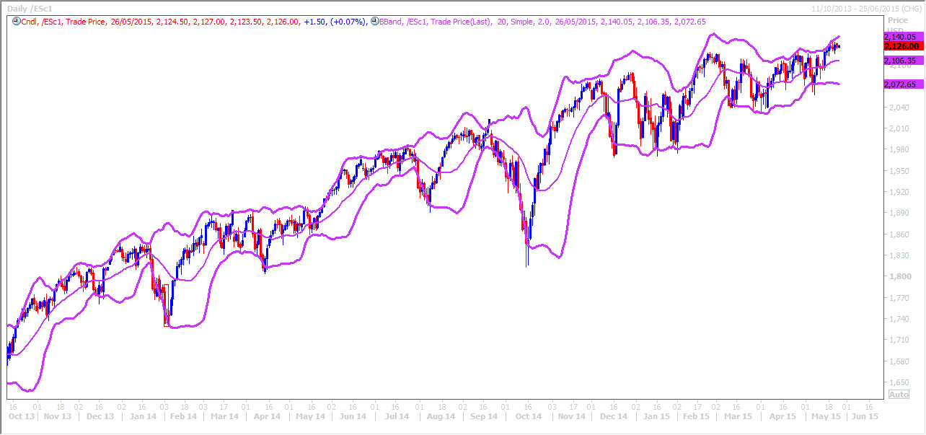

MACD - Moving Average Convergence Divergence Indicator.
The MACD is the difference between two exponential moving averages, which helps to measure short-term momentum compared to longer term momentum, signalling the current direction of momentum. The 26-day and 12-day exponential moving averages are the most common used parameters.
1. Crossover signals.
The MACD is quite a good indicator and one I think worth monitoring with the slow stochastic.
A bearish signal is generated when the shorter term MACD line (blue) crosses below the slower signal (red) line.
When the shorter term MACD line (blue) rises above the slower signal (red) line, a bullish signal is given. I prefer to use these signals as confirmation of a reversal of the trend, when combined with candle formations. Just as with the Stochastic, we need to wait for confirmation of an MACD crossover, with for example the break of trend line support or resistance. Negative signals in a bull trend make selling short a risky trade but are useful for a potential profit taking signal. Buying in to longs in a bear trend on a bullish signal, is also a risky trade.
As we know, low risk trading is buying in to a bullish signal in a longer term bull trend and vice-versa.
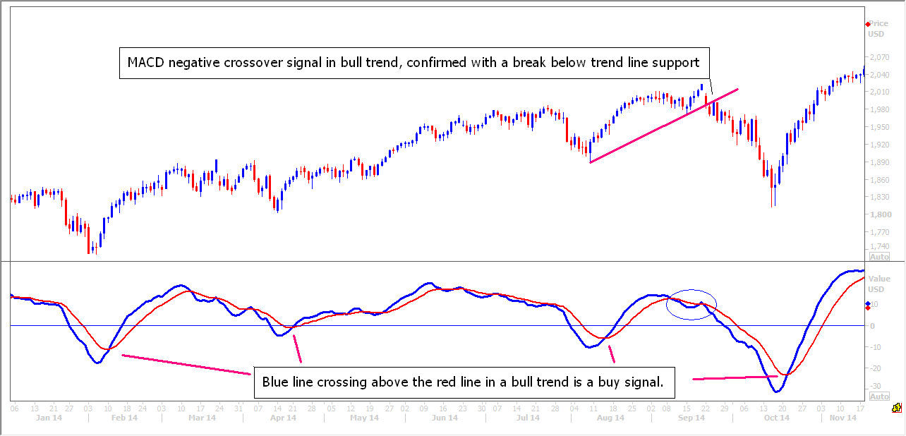
2. Divergence - Just as with the Stochastic and RSI Oscillators, the MACD divergence indicates a market may be running out of momentum.
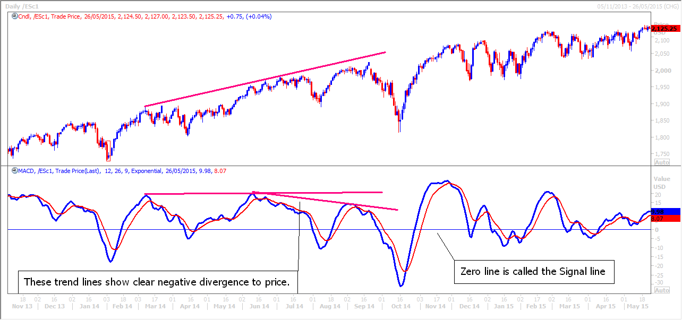
3. The zero (middle horizontal line) – when the MACD crosses above the zero line this is also a positive or bullish signal and when the MACD crosses below the zero line, this is a negative or bearish signal. However I would not use this as a trade signal, more as confirmation of the continuation of the existing move. Helpful if you already have a winning position, as it may help to keep you in the position in the hope of increased profit.
RSI – Relative Strength Indicator.
The RSI works in a similar way to the Stochastic Oscillator but I find the Stochastic Oscillator to be more effective.
The RSI ranges from 0 to 100. A reading above the 70 level in a bear trend indicates an overbought market and a good chance the price will pullback. An RSI reading below 30, indicates an oversold price in a bull trend and therefore the bull trend is likely to resume.
Just as with the Stochastic, selling in to a short position when the RSI becomes overbought, or buying in to a long position when the RSI is in a strong bear trend, is high risk and not advisable.
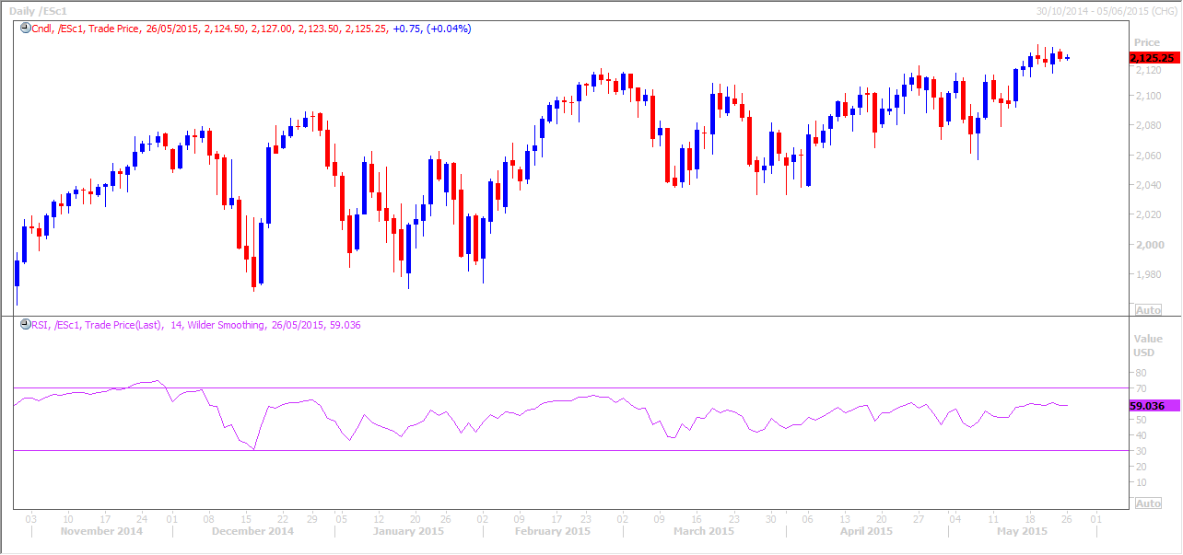
Again traders look for a divergence between the price and the RSI but they wait for confirmation before entering a trade. (Eg a break below a trend line when a negative divergence is seen). The RSI may be a useful tool only when combined with our other technical analysis techniques.
Fibonacci Series
An Italian named Leonardo of Pisa, or Leonardo Pisano was born in Pisa,Italy. It appears Fibonacci was a nickname given to him after his death. Fibonacci grew up in North Africa & helped to introduce the "Hindu-Arabic" number system into Europe used today,
Fibonacci completed his book in 1202 which explained the elementary school rules we use today for basic math. Many European mathematicians of his day were persuaded to use this Hindu-Arabic system rather than the Roman numerals system.
Fibonacci is credited with 'discovering' a series of numbers which has been used by mankind for centuries. Its use may have started as early as the Egyptians in the design of the pyramids as well as Renaissance artists. I will not go in to how you calculate these numbers here but you must be aware that they are important in the world of trading financial markets.
The Fibonacci series is present in physical proportions of the human body and many other parts of life and the universe. There are so many examples of the Fibonacci Series occurring in the natural world around us, eg in spiral formations in the head of the sunflower, the veins in leaves, the formation of shells. In a beehive, divide the number of female bees by the number of male bees, and you will get 1.618.
The Fibonacci series frequently appears in geometry eg. in the pentagons and hexagons in Islamic decorations and it was used in the design of Notre Dame in Paris as well as many more recent examples or design and architecture.
I actually do not know why the Fibonacci numbers work so well in technical analysis but I know that they do work extremely well. I probably use the Fibonacci retracement tool more than any other and in fact I believe you could identify reliable enough trading levels if this were the only technical analysis tool you used! It may just be that so many technical traders use Fibonacci because they are so easy to plot on a chart, that the numbers have such importance and effect on price movement!!
How do we use locate and use Fibonacci retracement levels in trading?
As we have discovered, markets move in trends over extended periods of time. However no market moves in a clear straight line. Price chops up and down within the longer term trend. Technical traders use Fibonacci retracements to find support in a bull trend & resistance in a bear trend. Fibonacci retracements are horizontal lines and all technical analysis software has this tool built in so they are very easy to use. Join two extreme points (high and low points) and the key Fibonacci ratios of 23.6%, 38.2%, 50%, 61.8% and 100% will appear across the area of this move. For me the most important levels are the 38.2% & 61.8%, followed by the 23.6% and then the 50%.
Note that I also use a 78.6% Fibonacci level on my charts. It is less important than the others but I like to keep an eye on it. Once the 78.6% level has been broken, remove the Fibonacci lines from your chart & look to redraw them.
The chart below shows a swing low and swing high joined with Fibonacci retracement lines. Note how the Fibonacci lines tie in nicely with previous low points in price. This importantly reinforces the strength of these Fibonacci support levels, as at each level the price had previously jumped higher.
The 50% level is not a Fibonacci retracement target or support, but traders use this level because of the tendency of markets to resume the longer term trend after retracing half of the previous move. As you can see in the chart above, the 50% line coincides with a good support level. The red ringed area shows how the last time this area was tested, price spiked off this area & the bull trend resumed. Note this was before the area had become a 50% Fibonacci support because we had not reached the high for the whole move yet.
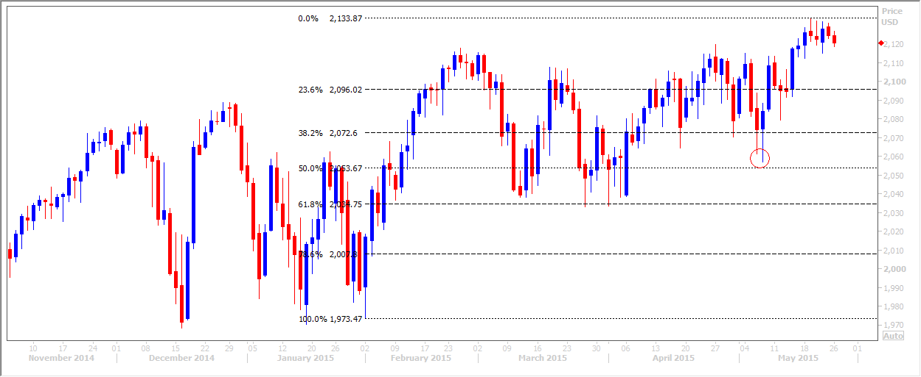
As you can see in the chart, this is an up-to-date example – The last candle on the right hand side of the chart is today’s as I write. Because the Fibonacci lines tie in so well with the previous price action it gives me good reason to believe this is a short term top for this market.
If the levels were out of sync with the price as in the example below it would give me a strong reason to believe we had not made a significant top in the market & I would look to redraw the trend lines over a shorter term period.
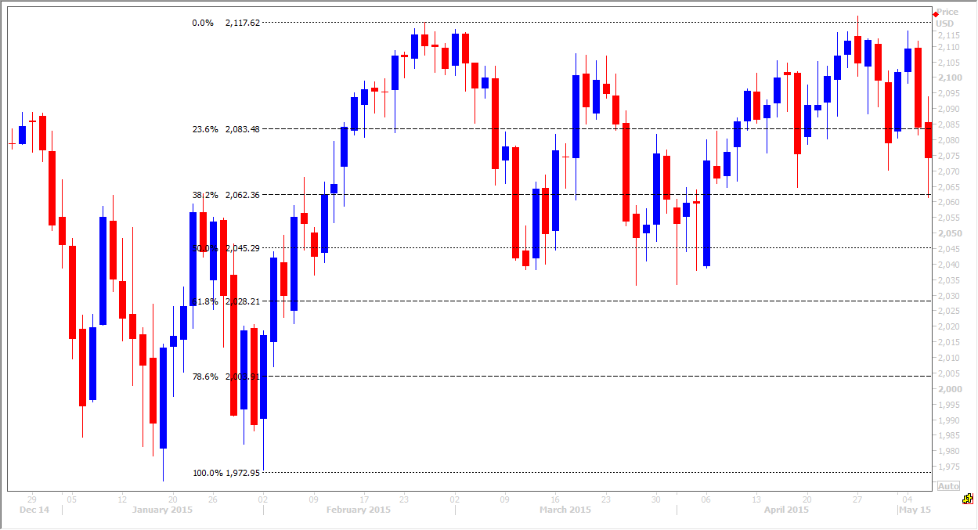
The same chart below has shorter term Fibonacci lives & appears more relevant because they tie in better with the price action.
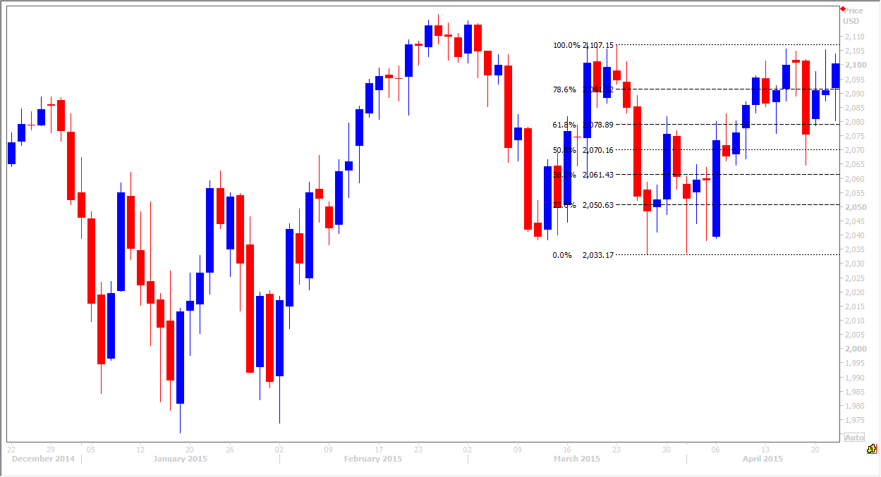
Once the market begins to pull back, traders can plot the Fibonacci retracement levels on a chart to look for signs of a reversal. Bear in mind that a break below one Fibonacci level will very often target the next Fibonacci support level. You do not know if or when the market will reverse at a Fibonacci level so as always, we need to use a stop loss just below the support. However it is not uncommon for price to spike a little below the Fibonacci support & then close just above. This would be considered a successful test of the support & could trigger buying in the market. Therefore it is wise to use a stop around half way to the next Fibonacci level.
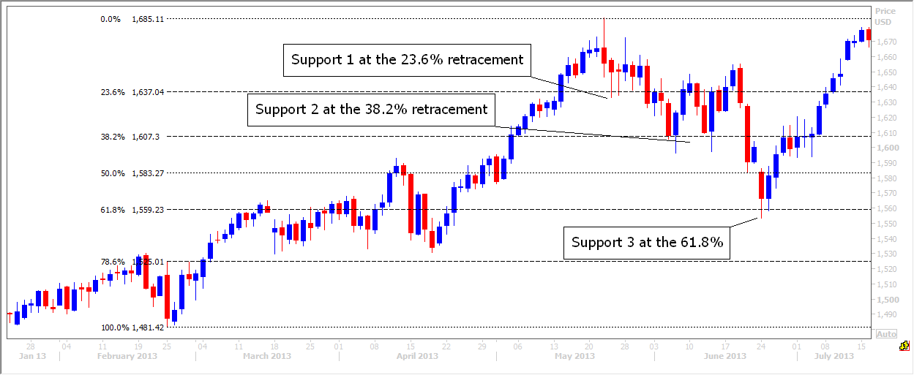
In the example above you can see how the price initially held support 1 at the 23.6% Fibonacci level. Buying here would have returned a nice short term profit on several occasions. However, eventually a break lower targets the next support 2 at the 38.2% Fibonacci. See how initially the price spikes just below this support on both tests. However the close above coupled with the big blue bodied candle suggests a bounce from here is expected. If you placed a buy order at the Fibonacci level with a stop loss around or just below the half way point to the next Fibonacci level you would have seen a profitable trade. In fact we managed a bounce back above the 23.6% Fibonacci on both occasions.
Remember a support or resistance level is only considered broken if price CLOSES outside the Fibonacci line. A small spike through the support or resistance is common, as ‘stop-hunters’ try to shake out the weaker traders and force them to stop out of positions, but false breaks are common & price can then recover to close just back inside the Fibonacci level.

If the price moves more than half way towards the next Fibonacci support level it is likely to continue on & test it. We can then try longs again at the new level, with stops around or just below the next half way point.
However, eventually a break lower targets the 50% Fibonacci level. Once this is broken we hit the next target & support 3 at the 61.8% Fibonacci level. Again a little spike lower leaves a small lower shadow or candlewick, followed by a close above the 61.8% Fibonacci level. The next candle retests this support & holds it perfectly. The longer term bull trend resumes from this point. If a bull trend correction reaches as far as the 61.8% this is often a golden buying opportunity as the trend often resumes from this point.
The Fibonacci levels also work nicely as targets when the longer term trend resumes. In the example below we can see how the Emini S&P recovered from a low after the 2008 financial crises. Drawing short term Fibonacci levels on our chart you can see how the levels worked as targets. A short term trader would have been able to buy on a break above one Fibonacci level & use the next Fibonacci level as a target for short term profit taking. When the price dips back to a Fibonacci level on short term profit taking this is an opportunity to buy back in to the market & look for the next Fibonacci target.
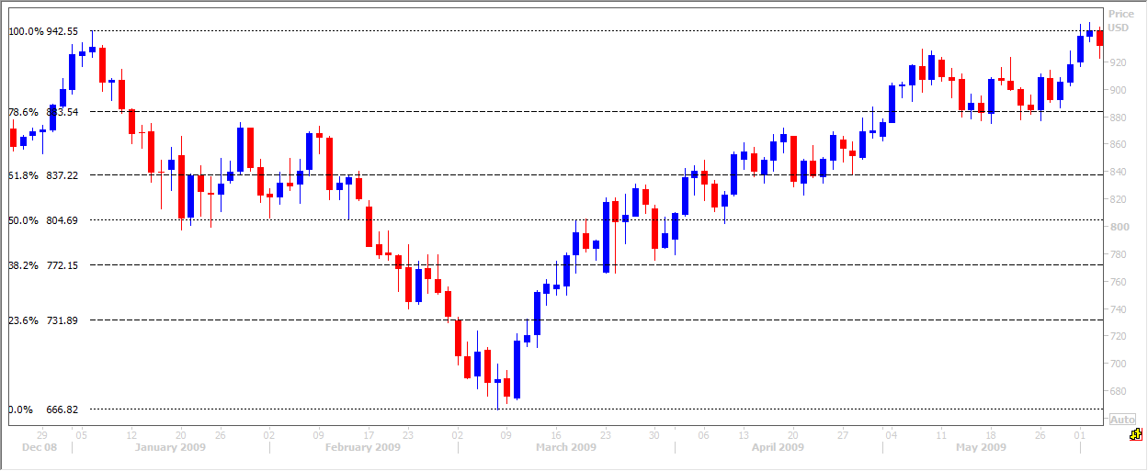
Very short term traders or ‘scalpers’ can use short tern Fibonacci levels as support & resistance to move in and out of the market.
The key to using Fibonacci in a live trading environment is to monitor several different time frames. We already understand the importance of this point because we know the traders with the biggest accounts are the longer term investors or funds. They have the real power to move the market & even change trends. Therefore, even as short term day traders, we must also be aware of the important Fibonacci levels on the monthly, weekly & daily chart. Just as you plot your trend lines & moving averages on these charts make sure to plot your Fibonacci levels.
Fibonacci areas of confluence
As we know, the key is putting all the technical analysis techniques together across the various time frames to build a picture of the market in your mind & identify all the important longer term & short term trading levels. Look what happens when we plot Fibonacci levels over different time periods.
In this example of the Emini S&P recovery after the 2008 financial crises we start with the monthly chart. We have drawn Fibonacci levels starting at the peak and ending at the bottom of the crash on the left hand side of the chart.
At the bottom of the market a bullish piercing pattern appears & is in fact the first big blue bodied candle for many months. This is a clear bullish signal indicating the end of the bear market. It is all the more important because it appears on the longer term monthly chart. This is not a signal one should ignore! See why a short term trader must study longer term charts??!! At the bottom of each of the troughs in the recovery rally, we also see very clear bullish candle formations. These also coincide quite closely with the monthly Fibonacci targets. Note we are using the Fibonacci levels here not only as resistance but also as targets, having spotted the reversal of the bear trend to a bull trend, with the candle formations. Just by studying the monthly chart it is pretty clear that a bull trend is developing with the trough of each pullback clearly marked by a bullish candle at Fibonacci support levels. Each new rally breaks above the next Fibonacci resistance & target.
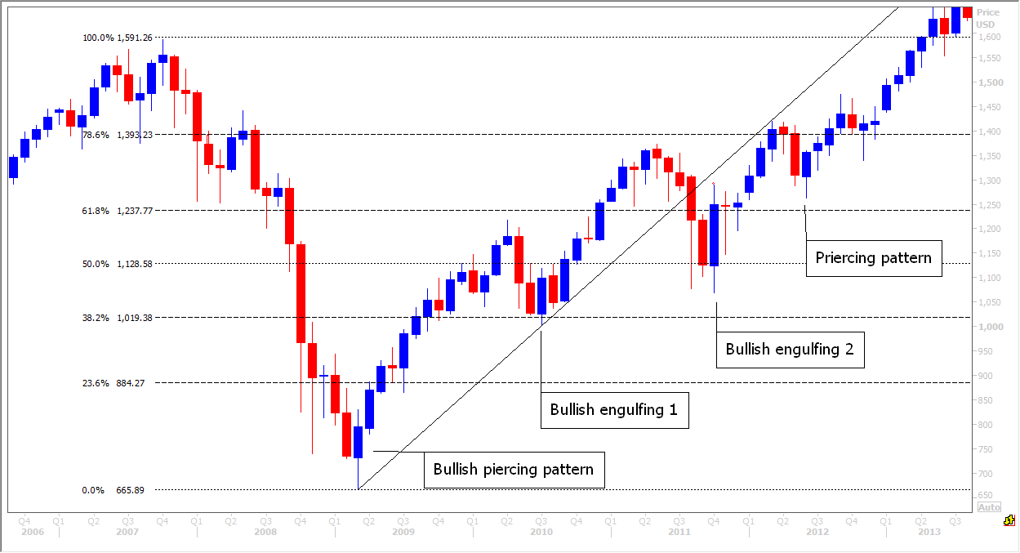
Moving on to the weekly chart below, we have added a new Fibonacci series, measuring the low of the crash to the first peak. Note how the price initially pauses at the 100 week moving average in the early stages of recovery (blue line). However once it has broken above in a further bullish signal, the 100 week moving average then works perfectly as a support area when it is tested twice. On the second test of the 100 week moving average as a support level, this also happens to be important Fibonacci support (blue circle). I have drawn a second set of Fibonacci lines at the first peak. Not only do we have the 38.2% Fibonacci support from the monthly lines at 1019 but also the 38.2% Fibonacci support from the weekly lines at 1007. This is absolutely key to successful technical analysis. I look for important areas of confluence such as these where support levels all tie in together. If three good areas of support were not enough to convince a trader to be buying here, we then get a bullish piercing (almost an engulfing!) candle to confirm the bounce off the important support area in the blue circle. Don’t forget we also have a bullish engulfing candle here (chart above). What more evidence could a trader need to buy in to the market here?
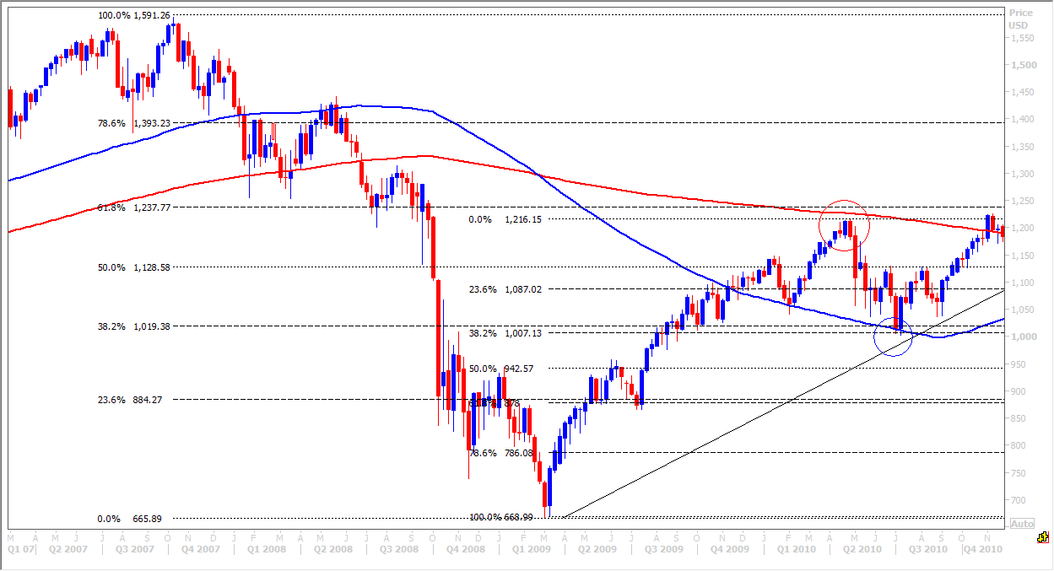Note how the 200 week moving average (red line) and the first monthly 61.8% Fibonacci level also worked perfectly as resistance as the price topped out in it’s first major peak in the recovery, just below here (red circle).
Moving in closer again we look at the daily chart over the same period, from the low of the crash. This chart obviously covers less data than the monthly chart but we can see more shorter-term trading opportunities here. Using the shorter term periods is like using a magnifying glass and the short term levels are more relevant to the day trader.
For almost a year the Emini S&P experienced a very strong bounce back after the crash ended. If we isolate the period of one year from the low in the daily chart below, we can see how the blue 100 day moving average crosses above the red 200 day moving average after just 4 months of recovery, in a very positive signal. This is at about the same time as the 100 week moving average is tested as a support level for the first since the price crossed above it. (If these were not good enough bullish signals, we are also testing the monthly 23.6% Fibonacci level at 884 as you can see in the chart above, although a bottom was only reach at 866).
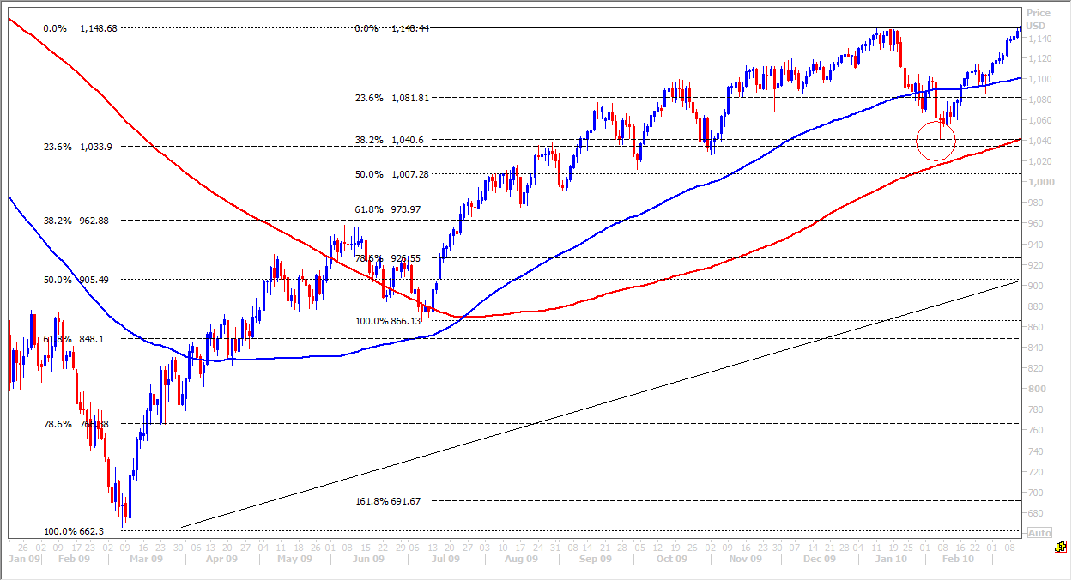
Price gains clearly accelerate higher from this point as more traders & investors spot the bullish signals and increasing numbers of buyers enter the market until we reach a short term peak towards the right hand side of the chart. The market has then become overbought & a healthy short term correction occurs. You can see I have drawn 2 sets of Fibonacci lines on the daily chart above. The first covers the whole move higher. The second shorter term set of Fibonacci lines are taken from the next significant trough, just before the middle of the chart....in fact just before the 100 day moving average crosses above the 200 day moving average. This second set of Fibonacci lines gives us another set of less important targets & support levels. Remember that the short term indicators and support & resistance levels are always less important than the longer term ones.
The first short term Fibonacci support at 1081 intersects perfectly with the blue 100 day moving average. I would therefore consider this to be a significant area of support & although the price does pause here, this area does little to halt the slide. We continue lower to the next target & Fibonacci support at 1040/1033 (red circle). Here we have two Fibonacci supports and therefore an area of ‘confluence’. We are on the look-out for key areas of support to buy in to longs, because we know we are in a longer term bull trend now. This is confirmed on the daily chart with the upward sloping longer term moving averages. Confluence areas where Fibonacci levels over different time periods over lap, are always more powerful. In this case the two Fibonacci support levels work perfectly (and are located just above the 200 day moving average support to give us more confidence) & the bull trend resumes, pushing back above the 100 day moving average for confirmation of the longer term trend.
To finish off this section on Fibonacci, I will show you how area of confluence can be seen on just one chart. The typical Emini S&P daily chart below shows 5 months of price action. You can see how I have begun with Fibonacci lines at the low point of 1970. This sets out the main short term framework for our Fibonacci lines. We then break this down looking for the next significant low. Very often this will be at or very close to the 61.8%. Look for it each time you draw your lines. I take this as my second point for the next Fibonacci lines, at 2032.
I then take a third point, being the low at 2056. We now have 3 sets of Fibonacci lines on one daily chart. This is all a short term trader really needs for day trading....as long as he is aware of the longer term levels of course. The over lapping lines are the areas of confluence which should act as strong support & resistance areas. This is where the trader would wish to initiate trades. The areas that overlap the most include the longer term Fibonacci lines & are the strongest. Other less strong levels are used as targets when a level below has worked as support. They can also be used as a guide on where to place stops. Place a sell stop on a long position just below the weaker level of support.
These overlapping areas of confluence give the trader confidence that all the historical support & resistance levels are lining up perfectly & therefore can be relied upon to initiate trades.
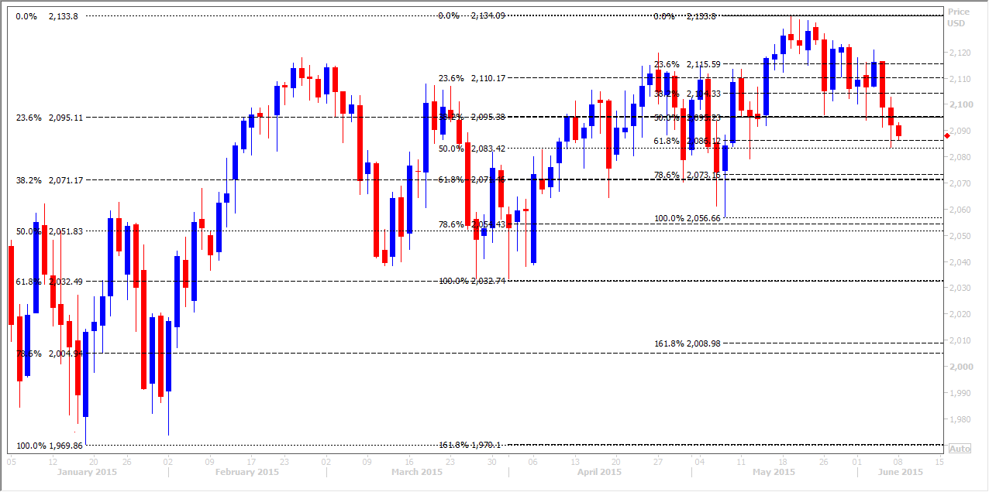
Ichimoku Cloud
The Ichimoku Cloud indicator can do what a lot of the indictors above do, but in one simple package. The system identifies support and resistance, trend direction and can also gauge momentum. It was developed by a journalist not a trader or technical analyst & is designed to be simple to use. When you first look at a chart with the Ichimoku Cloud system it looks complicated and unlike any other indicator you may have seen, but the concepts are surprisingly easy to understand and the signals are well-defined.
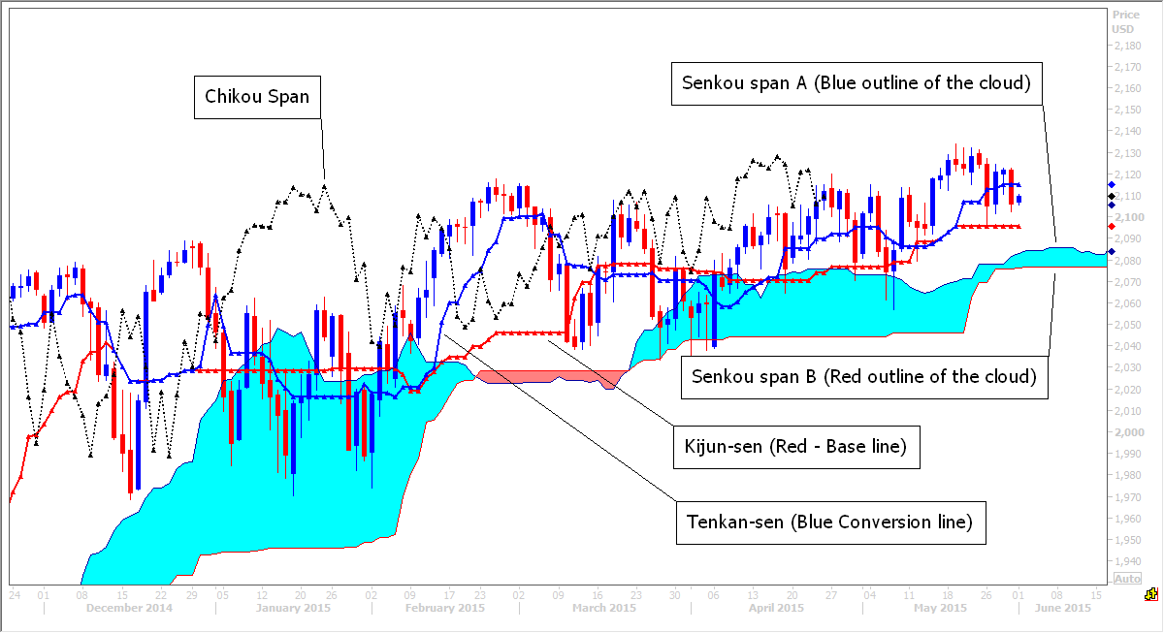

  - The Cloud (or Kumo) is the most prominent part of the system, when you first look at the chart. The Senkou Span A (blue cloud outline) and Senkou Span B (red outline) form the Cloud. The cloud is predominantly used to identify the trend. The blue cloud outline moves faster than the red cloud outline and works the same way as moving averages. Shorter moving averages are more sensitive and react faster to price movement than longer moving averages.
      - When prices are trading above the cloud the trend is positive or bullish, but in addition, when Senkou span A (blue) is rising above Senkou span B the trend is seen as a stronger bull trend, and a blue cloud is created, which makes spotting this strong trend very simple at a glance.
      - When prices are holding below the cloud the trend is seen as negative or bearish. In addition, when Senkou span B rises above senkou span A, the trend is even more negative and a red cloud forms. The red cloud makes spotting this strong negative trend very simple at a glance.
      - If prices are moving sideways within the cloud this is a more neutral scenario.
  - The cloud also works as support and resistance in itself. The outer boundaries of the cloud work as stronger areas of support and resistance, but the whole cloud will also work as support and resistance. It’s calculation shifts it forward by 26 days and therefore support and resistance areas at the edges of the cloud are projected in to the future.
You can see in the chart above, how the cloud has worked perfectly providing support throughout this period in the bull trend.
  - Chikou span is the black dotted line you see in the chart and acts as a sentiment indicator. Very simply, if the Chikou span is holding above the price action, this is seen as positive and bulls have control of the market.
  - If the Chikou span is holding below the price action, this is seen as negative and bears have control of the market.

  - Because the cloud is the most visual part of the system it is easy to focus on this and pay much less attention to the other parts of the system. However crossover signals are equally important.
Both price & Conversion line crossover of the Base line provide trading signals - The thick blue Conversion (or Tenkan-sen) line works very much like a 9 day moving average. The thick red Base (or Kijun-sen) line works very much like a 26 day moving average. (In fact these are easier to calculate manually as there are simply the average of the 9 day high & low and the 26 day high & low). Just like the 9 day moving average, the Conversion line reacts much more quickly to movements in the underlying price, than the slower Base line.
      - A crossover of the price above the base line is used to give a buy signal. In addition, a Conversion line cross above the Base line is used to generate another buy signal.
      - A crossover of the price below the base line is used to give a sell signal. Another bearish sell signal is given when the Conversion line crosses below the Base line in a bear trend.
I find that the Base line itself also can work well as support in a bull trend & resistance in a bear trend.
*Remember that we are only looking to buy on a bullish signal when the prevailing trend is already positive. Vice-versa we are only looking to sell when a bearish signal is given, when we are already in a negative prevailing trend.*
6. If price breaks below the cloud this is a negative bearish signal & indicates the bull trend has been broken. If price breaks above the cloud this is a bullish signal & indicates the bear trend has been broken.
You can see how the Ichimoku cloud is designed to give indication and strength or momentum of the trend. Price trading above or below the cloud and the colour of the cloud itself allow the trader to quickly read these signals with a quick glance of the chart. A blue cloud also works as support zone in a bull trend and a red cloud works as a resistance zone in a bear trend.
Bullish Signals:
- Chikou span holding above the price action.
- Price moves above Cloud to indicate a bear trend has ended.
- Cloud turns from red to blue to indicate strengthening bullish momentum.
- Price moves above the Base Line (Kijun-sen)
- Conversion Line moves above Base Line – buy signal.

Bearish Signals:
- Chikou span holding below the price action.
- Price moves below Cloud to indicate a bull trend has ended.
- Cloud turns from blue to red to indicate strengthening bearish momentum.
- Price moves below Base Line (Kijun-sen)
- Conversion Line moves below Base Line – sell signal.

*Note that just like moving averages, the Ichimko cloud system does work well in upward or downward trending markets, but does NOT work well in a market that is trending sideways and is likely to throw out many false signals.*

Module 6: Various Classical Patterns - Understanding the various types of classical chart patterns and the trading decisions associated with them.

Head and Shoulders
Head & shoulder a favourite pattern of mine. Not so easy to spot but when the pattern is confirmed it is quite reliable. This reversal pattern signals the end of a bull trend and a reversal to a bear trend.
The important point to note is that the head & shoulders pattern is only relevant after a sustained bull trend. If you see the pattern forming in a sideways trend or in a bear trend, this is not a head & shoulders pattern.
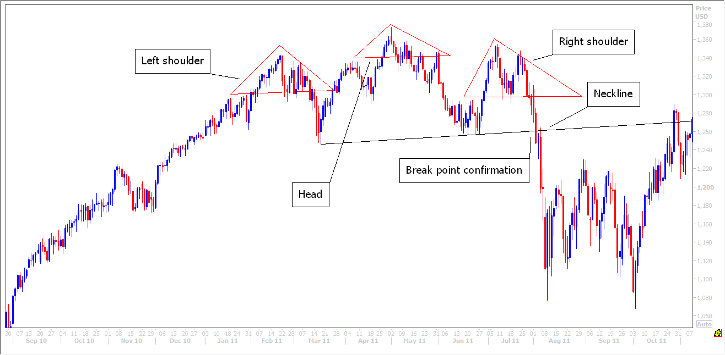
In the head & shoulders example above you can see a sustained bull trend in the right hand side of the chart leading up to the head & shoulders pattern formation. A bull trend is identifies as we know by successive higher highs & higher lows. The head & shoulders clearly demonstrates a breakdown of this trend.
The left shoulder gives no cause for concern as prices continue higher after the left shoulder peak. The pull back of the left shoulder may or may not be low then the previous pull back. The head forms with a new high in the bull trend, but is followed by a significant sell off, more than would be expected in a bull trend. The base of the pull back may be just above, equal to or below the base of pull back of the left shoulder. The lower the base of pull back however, the more effective the head & shoulders is likely to be.
The right shoulder then gives the main cause for concern. The peak is below the head & may even be below the peak of the left shoulder – this signals that the bear trend has ended and we no longer achieve new highs. We are now alert to a potential Head & shoulders pattern forming but this could just be a sideways trend developing, so we must wait for confirmation. (Too many times I have traded this pattern, selling short before confirmation has been seen, leading to a losing trade).
Confirmation of the formation of the negative reversal pattern comes with a break below the neckline. The neckline is drawn by connecting the two low points of the two shoulders and extending the trend line to the left. Once the neck is broken, we have our sell signal. The price heads lower & quite often collapses sharply.
We can gauge a price target for the pattern by measuring the distance from the peak of the head (where the market topped out) to the low that followed (start of the right shoulder). If you project this lower from the neckline, this gives you a measured target for the pattern. This target can be exceeded if the bear trend continues lower.
Note how the neckline continues then to act as resistance when the price bounces.
Inverse head & shoulders.
This is the exact reverse of a head & shoulders pattern & is therefore only found after a sustained bear trend. It does not appear in a bull trend or a sideways trend.
This reversal pattern signals the bear trend has ended & reversed to a bull trend. The inverse head & shoulders is less common but just as reliable.
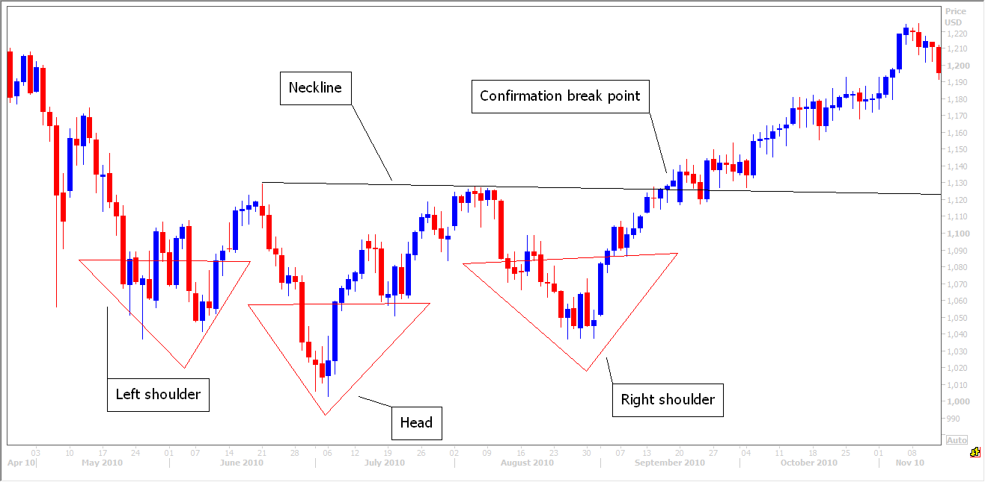
In the example above, the market is in a bear trend as we form the left shoulder. The head forms to continue the bear trend, but the strong bounce that follows gives bears cause for concern. This high point will form the second point of the neckline, but we do not yet know that a potential inverse head & shoulders pattern is forming.
The market sells off again but the next low point is higher than the head and in line with the left shoulder. Now we are alerted to the potential formation of an inverse head & shoulders. The price moves straight back up to the neckline & once this is broken we have a buy signal. Although this pattern is less common than the head & shoulders, the reaction is often more violent, providing fast profits.
The examples above show quite symmetrical patterns with the left & right shoulders similar in shape, size & duration. This is not always the case & can therefore make spotting these patterns difficult. Be aware that the shoulders do not have to be the same shape, size or form over a similar period of time. One can be significantly deeper than the other, one low or high point can be at a significantly different level. The neckline need not even be straight, it could be at quite a sloping angle. It takes practice and experience to get used to spotting this pattern but it is worth the effort. I have spotted many significant market tops and bottoms from the formation of these patterns. In fact I called the 2007 stock market crash and the 2011 mini crash, just by spotting the head & shoulders patterns in the Emini S&P.
Double Tops and Bottoms
Another one of my favourites, again because it is one of the most reliable patterns & commonly seen.
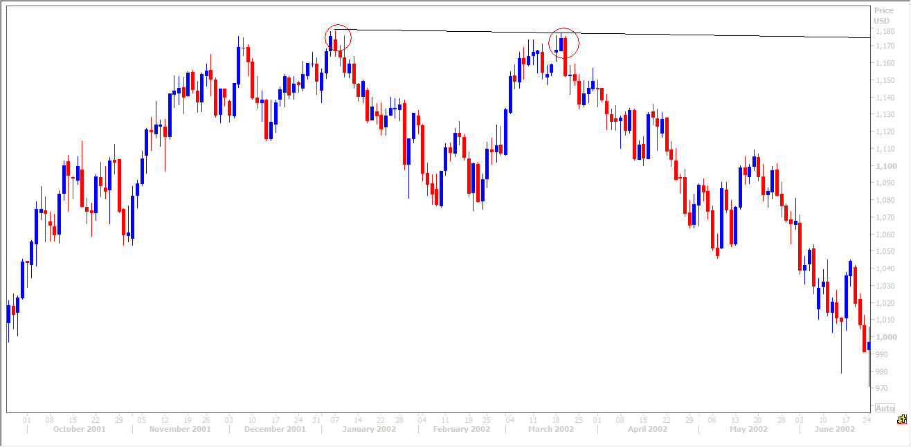
A double top is seen after a bull trend when a peak has been reached that is followed by a significant pullback. This pull back is often below the low of the previous pull back in the bull trend, which alerts the trader that the trend may be ending. When the peak is retested on the next move higher, this resistance level proves unbeatable.

Watch for a negative candle at the peaks, especially the second peak, for confirmation – eg. Bearish engulfing or dark cloud cover.

A double bottom as you might imagine is a mirror image of the double top. Again look out for bullish candle patterns at the two low points in the double bottom. In the example below we see a bullish engulfing in the first low and a piercing pattern in the second low point to help confirm the double bottom formation.
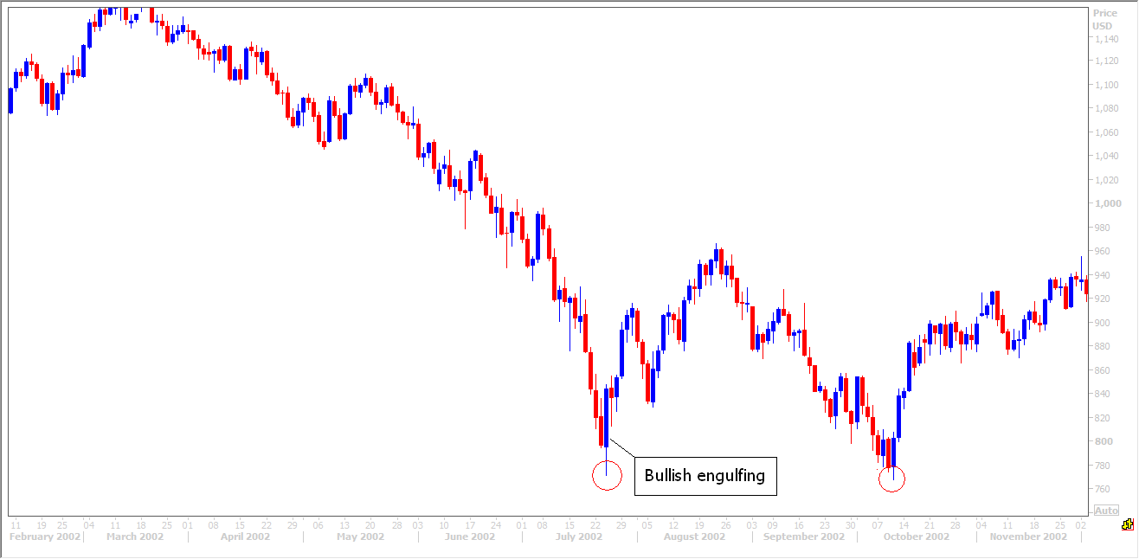

Triple tops & bottoms.
These are extremely rare. The general rule is that double bottoms hold but triple bottoms do not. This means that if a double bottom is formed but after a bounce the price sinks again to test the double bottom support, more often than not, the double bottom pattern will be broken and the bear trend will resume.
However if you do spot one of these rare patterns it is significant & it is worth paying attention to it.

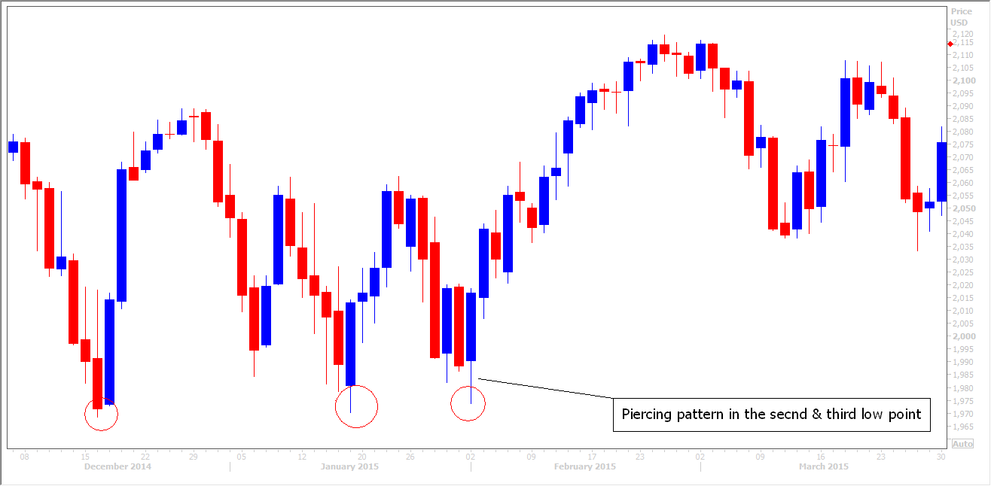
Again we look for bullish candle patterns at the low point of the triple bottom pattern to confirm. In the example above, the second two low points have bullish piercing patterns.

The patterns above can be traded in any time frames. However as is the rule with all aspects of technical analysis, the pattern is more significant on a longer term chart (monthly, weekly & daily chart). The patterns can still be traded in the short term if spotted on hourly charts or even shorter time frames, but of course the patterns will be smaller.
Triangles
Symmetrical triangles give no particular clue to direction as the price could break higher or lower. However if the triangle appears in a bull trend, a good chance the break will be higher and vice versa. Measure the mouth of the triangle to project a measured target on the breakout. In the example below the price breaks to the downside, despite being in a bull trend & fulfils the target before recovering and resuming the trend.
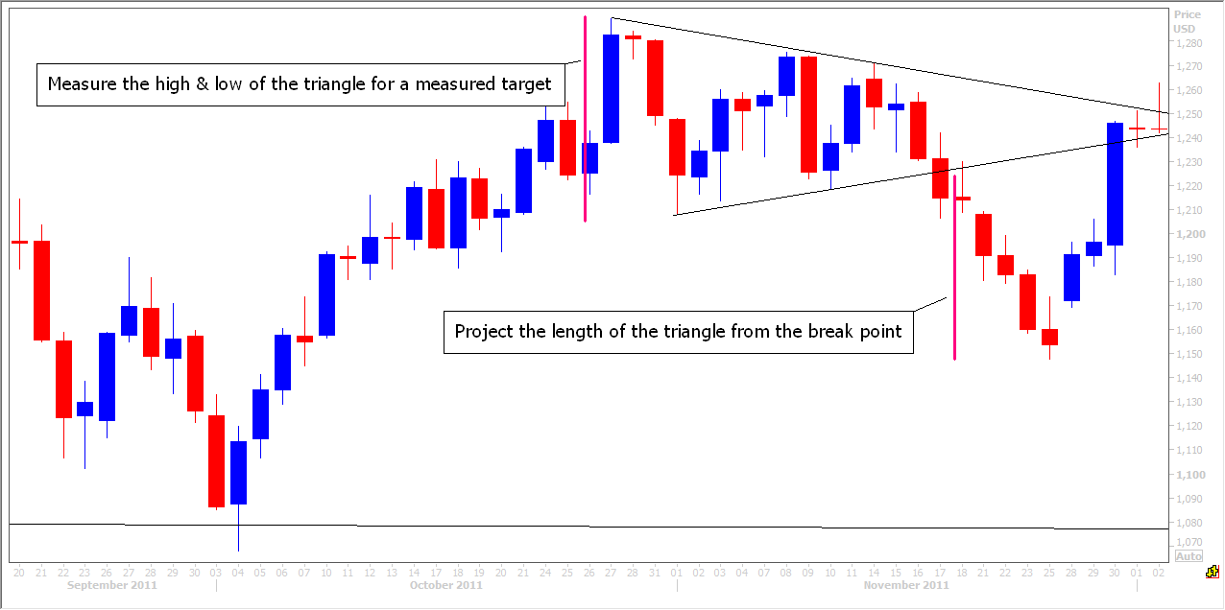

An ascending triangle is often a bullish pattern as it shows buyers prepared to pay higher prices on each pullback. Eventually the buyers overwhelm the sellers and price breaks-out higher. Again, measure the mouth of the triangle to project a minimum measured target on the breakout. Be ready to buy a break above the upper trend line.
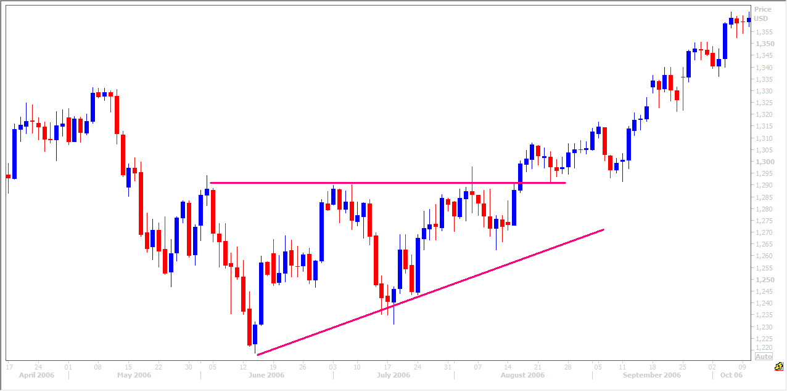

A descending triangle is the reverse & therefore often seen as a bearish pattern where we look for a downside breakout. However the direction of the breakout is the important factor so never enter a position in the hope price does breakout in the direction you have guessed. Wait for the breakout for confirmation.
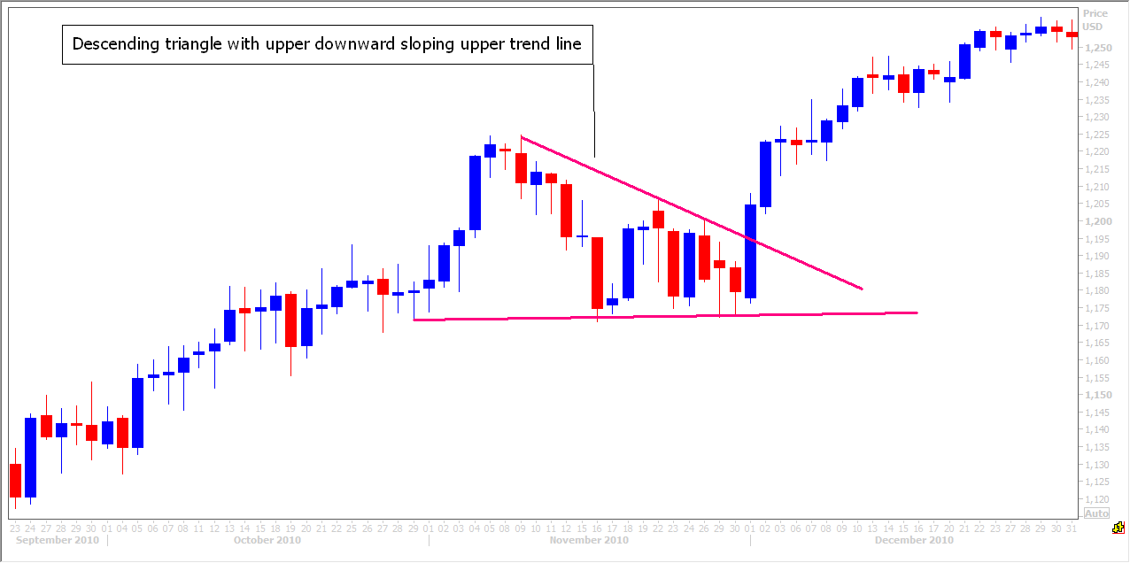
Flags are continuation patterns formed when price pauses within a trend. A flag is formed when price trades with a short term channel pattern, with no convergence between the trendlines. The trend is expected to continue when the price moves above the upper trendline. Flags are quite common in bull trends. As in the examples above, be ready to buy a break above the upper trend line.
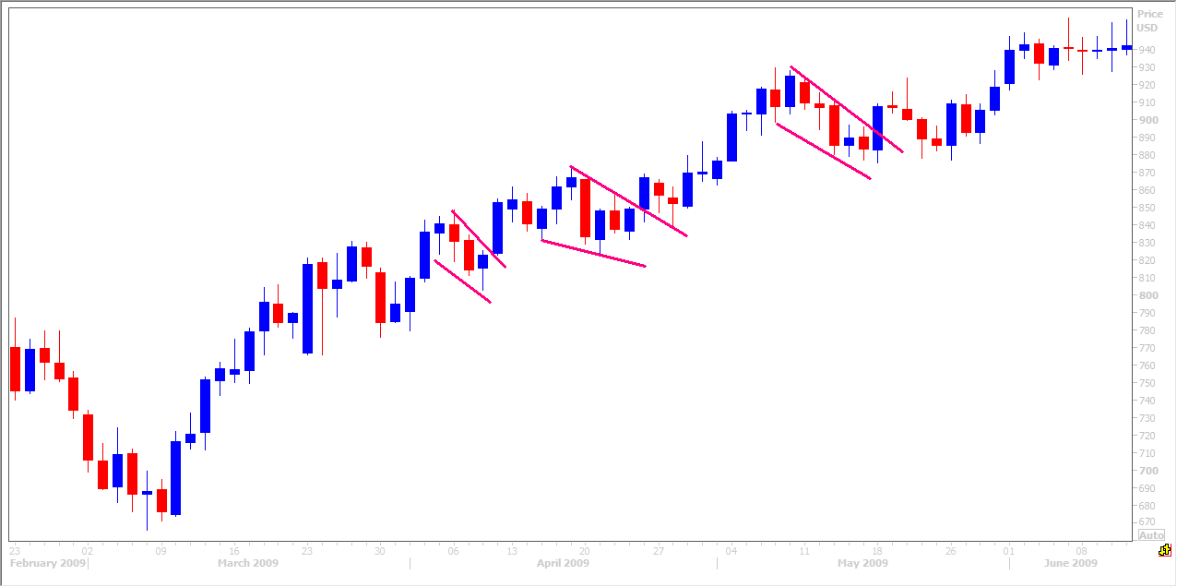
Gaps
A Gap is an empty space between two trading periods. A breakaway gap forms at the start of a trend as in the chart below.
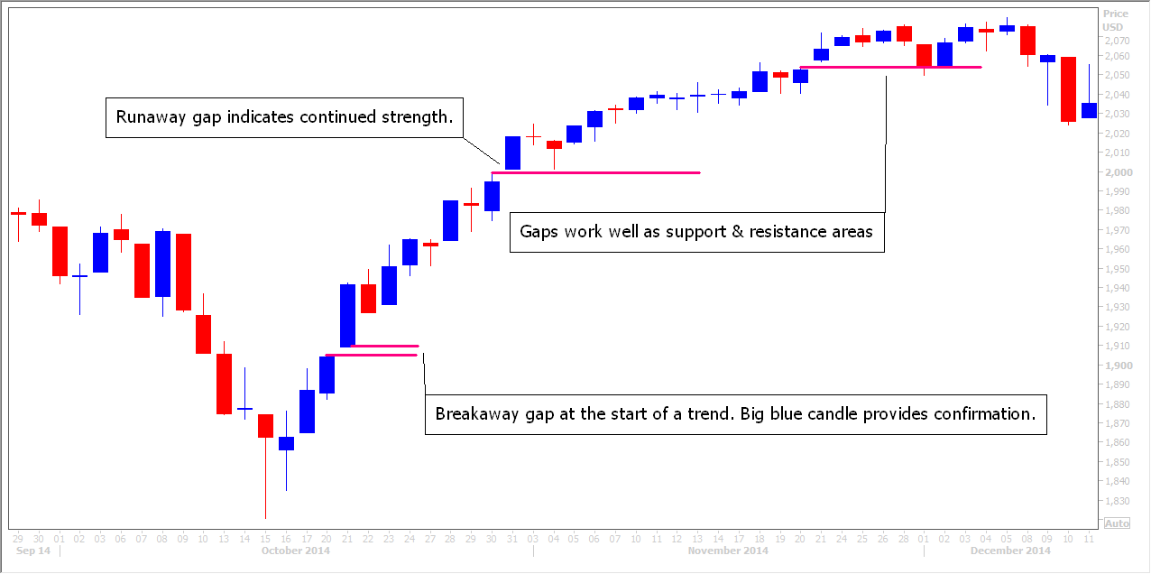

A runaway gap is seen as the trend develops and is confirmation of a strong trend. When prices gap higher in a bull trend it shows buyers are very keen to jump in to the market as it opens. Note the bullish big blue bodied candles above the gaps. A gap open above a resistance line would help confirm a break above the resistance & would be a buy signal.
An Exhaustion gap signals the trend has become exhausted and the bears are gaining control. Price gaps open below the low of the last trading period & sells off right from the open to form a large red bodied candle. This signals the positive trend has ended and further moves to the downside are expected.
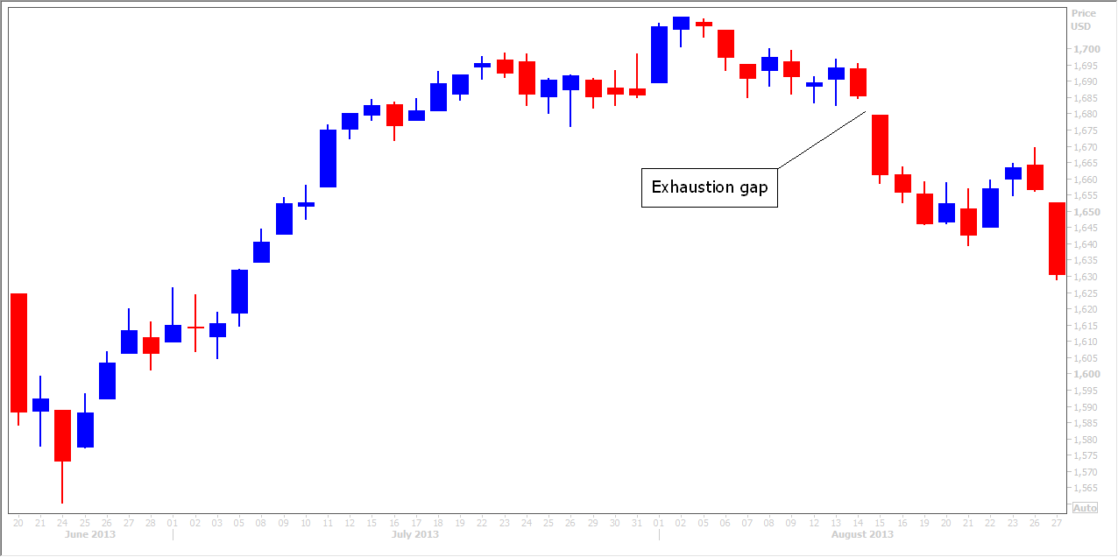
Volume & Open Interest
Volume confirms the strength of a trend. The larger the volume the more we can expect the existing trend to continue. Obviously if prices are rising on high volume there are a lot of buyers reinforcing the trend.
For the same reason therefore, the loss of upside price pressure in an uptrend or downside pressure in a downtrend will show up in the volume figures before presenting itself as a reversal in trend. A big movement in price which is not confirmed by volume is seen as questionable.
Open Interest is the total number of outstanding contracts that are held by market participants at the end of each day. Therefore this measures the flow of money into the futures market. Increasing open interest means that new money is flowing into the marketplace and has the same effect as rising volume in reinforcing the trend. Declining open interest means that the market is liquidating and implies that the prevailing price trend could be coming to an end. The smart money exits a bull market before the bull market reverses. If open interest is declining after a long bull trend this indicates the larger players & investors, or ‘smart money’ professionals are profit taking as they see values of stocks becoming expensive.
This is worth mentioning but is much less relevant to a day trader.
Module 8: Putting it all together – areas of confluence.
Here is an article I wrote about the US Dollar index on June 3rd 2015. I put all the pieces of the puzzle together, using moving averages, trend line, stochastic oscillator trend lines & Fibonacci retracements.

The US dollar has spent the last two weeks recovering from the Spring sell-off. However, the charts are now telling me that the sell-off is resuming and that the summer could be quite negative period for the dollar.
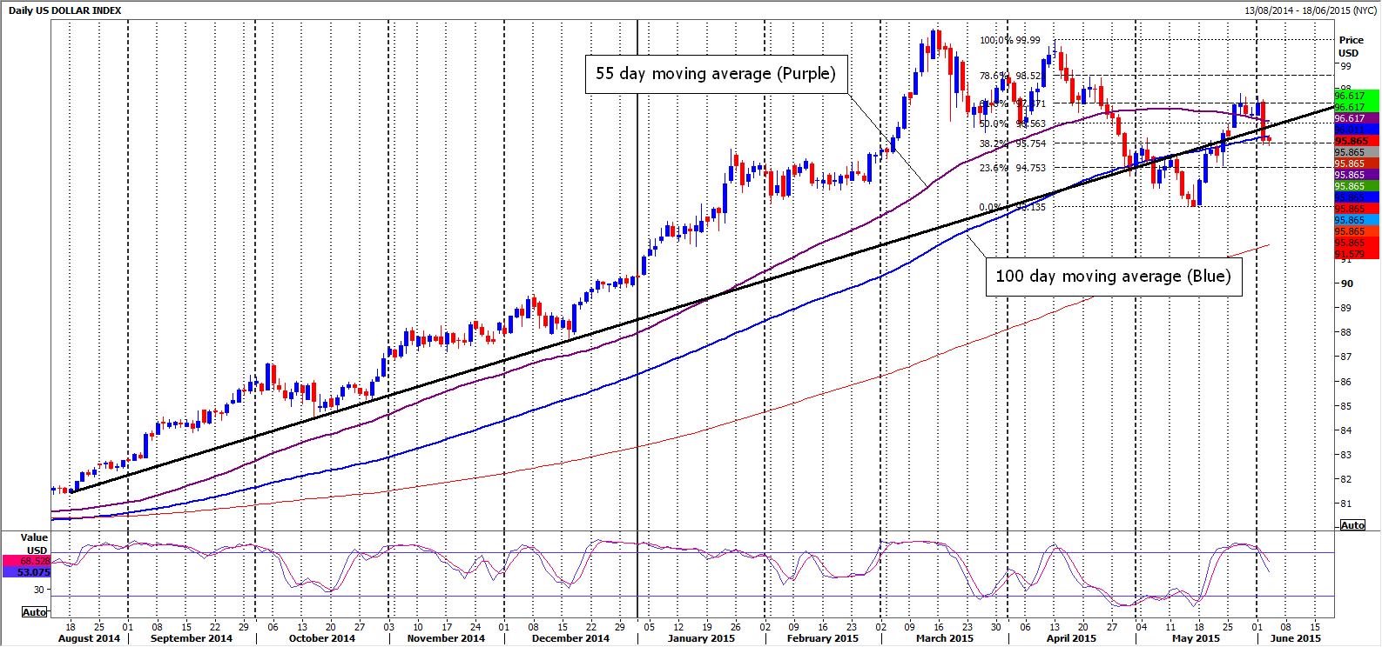
For me the key to direction is the thick black trendline you see in the daily chart for the dollar index above. Having become very oversold on the daily stochastic, the dollar index staged a good recovery in the second half of May, but this week has seen quite a sharp sell-off. We have now closed back below the black one year trendline, indicating that the bears are gaining the upper hand once again. The fact that this latest peak is well below the March and April peaks, indicates the start of a more negative medium-term trend.
Now let’s zoom in on the more recent activity in the daily chart below. The purple 55 day moving average had acted as quite good support last week, as we hovered just above it, but the dramatic break lower yesterday 2nd June, not only took this out, but also the one year trendline and the blue 100 day moving average. We closed back below this 100 day moving average which is another negative signal.
If you look at the slow stochastic oscillator at the bottom of the chart you can see how we had become quite overbought in the last week of May. The fact that we did not remain overbought for more than a week, indicates that a bear trend is developing, as bear sellers are taking action quickly when they see their chance. In a bull trend markets can and do stay overbought for significant periods of time. In a bear trend, overbought conditions tend to act as a sell signal, when strong resistance is reached.
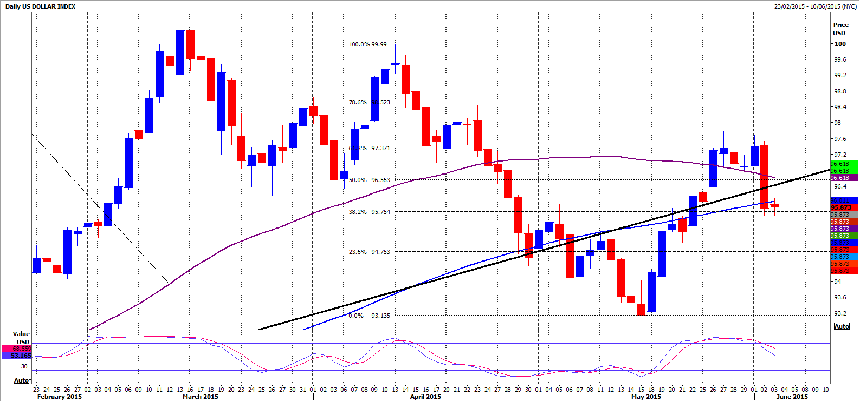
Another significant factor is that the rebound from mid-May recovered 61.8% of the sell-off from the peak in April. If you have a look at the Fibonacci lines I’ve added in the chart above, you can clearly see how the dollar index tried on three or four occasions to break through this level at 97.37, but on each occasion failed to close above this resistance. Another reason why bears felt they were ready to push the price lower.
The 55 day moving average (purple line) has clearly turned and appears to be heading down for the first time since late 2013. It is also quite rapidly now approaching the 100 day moving average and it could be only a couple of weeks before we see a negative crossover. This would be an additional longer term sell signal.
If you look at the chart below, you can see I have added two red channel trendlines.
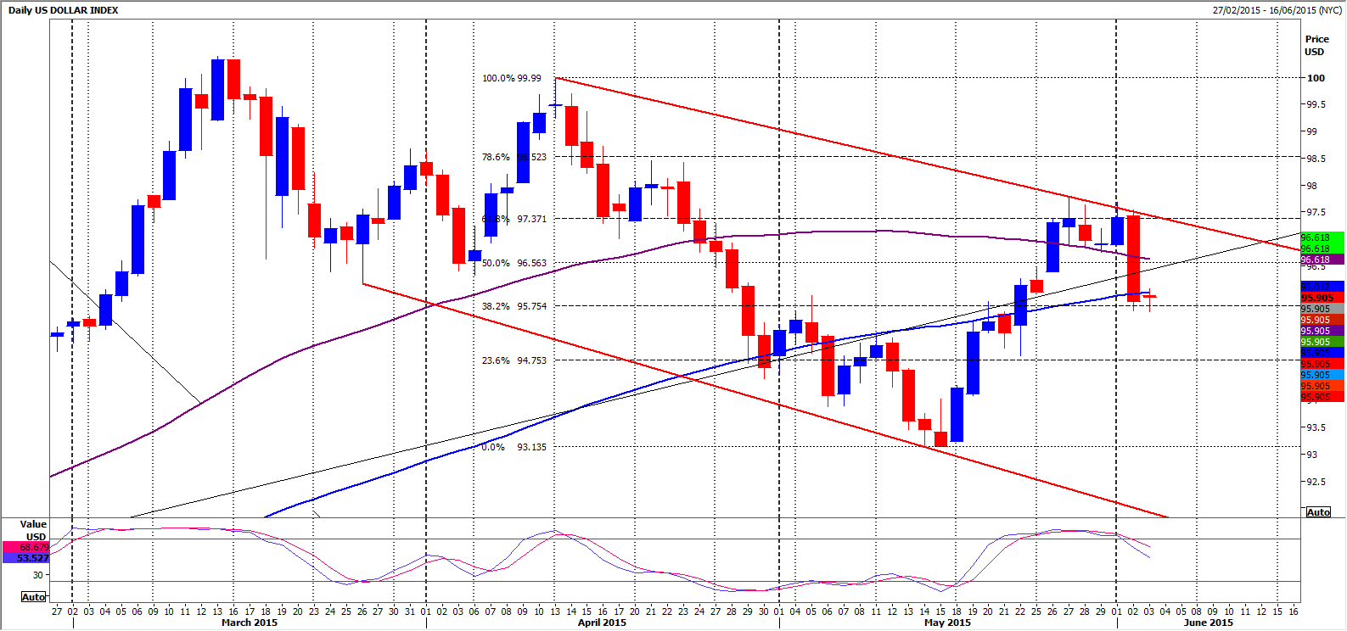
The parallel lines highlight the negative trend I’m talking about. Another close below the 100 day moving average, should confirm further moves to the downside to unwind the overbought stochastic oscillator. A break below 95.50 should then target 94.75 and 94.00. Below here we could be testing the May low of 93.14. This move, of course will not be one in one straight line, when markets trend, they chop up and down on the way to their target, but the May low will then be very significant if tested in June. If this is the bear trend that I suspect it is, this point will be broken and we will target 9250, then the lower trendline of this channel, which should be somewhere around the 91.75/50 area.
This should also roughly coincide with the 200 day moving average and should therefore offer significant support. We would be looking for a bounce from here.
So I have clearly laid out my case for a negative outlook for the US dollar index, but what would force me to change my mind? The first step would be for the price to reverse and close back above the trendline at 96.50. Secondly, I would need to see a sustained break above the upper channel trendline, meaning at least the two-day close above 97.40.
Summary
a. How do I use my new knowledge to identify low risk trading opportunities?
    - Identify the prevailing trend using trend lines, moving averages & oscillators.
    - Identify the important confluence levels of support in a bull trend or resistance in a bear trend, where trend lines, moving averages, Fibonacci lines etc intersect, paying special attention to the longer term chart levels.
    - Only enter trades in the direction of the prevailing trend, at strong levels & place a stop at a level that would clearly signal the strong level has been broken & the price will continue to move against you.
b. What is a stop loss and where do I place it?
1. A stop loss is an order that will automatically close your open position when a price is traded. You MUST always enter a stop loss when you execute a trade or when you enter a ‘limit open’ trade. (This is when you enter a buy order below the current trading price or a sell order above it).
2. As soon as you start to rely on mental stop loss orders – when you watch the market and decide to exit manually, when the price hits your mental stop loss price – you may as well just throw all the money in your account away. You will hesitate and fail to execute the stop, in the hope of a rebound in price to save you. Taking losses is incredibly hard for human beings to do without emotion. IT HURTS TO TAKE A LOSS. You must therefore automate the process and leave a stop loss order in your order book.
The losses will run away and become out of control. Sooner or later I can pretty much guarantee you will lose everything.
c. How do I manage a trade once it has been executed? – Once executed you already have your stop loss in place to ensure your losses are limited. You should also have a take-profit target for the trade, entered in to your order book. As the trade moves in to profit and in particular as the price moves in your favour through minor levels you have identified on your chart, move your stop up towards your entry price to reduce risk. Once the price has moved the same amount of pips as the amount of your stop loss, you can move your stop to your entry price to ensure you have a risk free trade.
Limiting your risk by moving your stop loss in this way leads to stress free trading and ensures a greater number of profitable trades.
e. Why would I use a stop to enter a trade? When a market is in a strong directional bull trend, price may not pull back enough for you to enter a long position at a suitable support level. Therefore the only way to get in to a low risk long position is to buy when the price breaks above a strong resistance level. When this happens the market is telling you that the buyers continue to dominate and a new leg higher in the bull trend is starting. Manually buying a break above resistance is very hard to do. You will sit there and watch the price jumping about and you never know when to pull the trigger.
If you have a buy order at a support level and you know you want to buy it is often wise to have an additional stop ‘buy-to-open’ order just above a resistance level so you do not miss the move. You will of course have to then enter a stop loss order as soon as the buy stop order is executed.
Module 9: The Golden Rules of survival & maximizing profit
To be a successful trader you must ensure you learn and ingrain good habits in to your trading psychology to increase your chances of becoming a profitable trader in the longer term.
The process of trading is just as important as the profits, but it often gets overlooked, especially by traders just starting out. All they think they need is hot picks from some guru and a bit of capital and they'll be on their way to profitability.
How hard can it be? I have a 50/50 chance of winning on a trade and as long as I use a stop loss I should be able to make money quite easily.
But trading doesn't work like that (at least not for the vast majority of traders). Trading is a skill and needs consistent effort and discipline to get any good at it.
Market Psychology is the key to consistent success.
PSYCHOLOGY:
- Identify the trend according to the time period that you trade and never open a position against this trend. It sounds so simple but it is too easy to see a bull trend that you did not manage to buy, because prices did not dip to your entry level or raced away from you and you did not want to chase it. Next thing you find yourself looking for reasons to go short just only because the market has rallied. Traders do it all the time...they know they should be long but they think it cannot go any further at this stage and find themselves shorting in to an uptrend only to lose money. They step back and think how did I get short when my original plan was to buy in to longs?

''Success depends upon previous preparation, and without such preparation there is sure to be failure.'' Confucius

- The professional trader buys BECAUSE prices have rallied. Buying strength works. The rule of survival is not to "buy low, sell high", but to "buy and sell higher" or ''sell and buy lower''. Buying a break above a resistance level is a good trading strategy that works over time but many of us find it hard to do because we think that logic tells us what goes up must come down. In fact what goes up in financial markets often keeps going up. It is wiser to try to jump on to a moving train and catch a ride than to stand in front of it and hope it stops.

- Only enter a trade once it has been well researched and planned so you have full confidence in your decision. Do your own research, never trade on someone else's hunch. All the work on a trade has to be done before it is entered so you already know where you will exit, whether the trade goes in to profit or loss. You need to know your entry price, your stop and your targets. You need to know when you will be trailing your stop to protect profits.

Trading is only stressful when you have not made a proper plan of each stage of the trade, as you are then forced to make rash decisions, which will be dominated by emotion in a moving market. That is when panic or greed dominates your thought process. Make a plan and stick to it, do not change your exit plans once in the trade. ‘Plan your trade and trade your plan’

'The general who wins the battle makes many calculations in his temple before the battle is fought. The general who loses makes but few calculations beforehand.' Sun Tzu

- Be patient. If a trade is missed, wait for a correction to occur for a second chance to enter the trade, or be ready to buy a break above resistance in a bull trend (or sell on a break of support in a bear trend).

"My first rule is not to lose money. Losing an opportunity is minor in comparison, because there are always new opportunities around the corner." - Burt Dohmen

- Be patient. Once you have entered a trade let the market do the work. Time is not a factor. You have already planned your stop and your ''take profit'' target level but you do not know how long it will take for one of these exits to be hit. Watching the price move about when you have an open position will only cause you to doubt yourself.

- Be patient. Hold on to winning trades until they hit your target. Don't take a small profit because of your emotions. Stick with the plan you made before entering the trade as this was when you were calm, unemotional and focused.

"We must remove the emotional element as quickly as possible in trading. If you can do it before you put on a position, you have a good start."

- Never ever move your stop losses further away to increase your potential loss. You will diminish your risk/reward ratio which is key to your long term survival. You waste mental capital when you nurse a losing trade for longer than planned. You miss out on the next opportunity that could have made a big profit and covered your loss on this trade.

"Experienced traders control risk, inexperienced traders chase gains." -Alan Farley

- Never, ever under any condition, add to a losing trade, or "average" into a position in the hope it will turn in your favour.

“The elements of good trading are: 1. Cutting losses, 2. Cutting losses, and 3. Cutting losses. If you can follow these three rules, you may have a chance.”
-Ed Seykota

- Keep a trading journal. Make notes on what worked and what did not work. What should be repeated and what should never be repeated! Learn from your mistakes and your successes. Regularly review performance, and improve.

''It's okay to make mistakes. Mistakes are our teachers - they help us to learn.'' John Bradshaw

- When you suffer a severe loss or even make an abnormal profit take a break and stop trading for several days, may be until the end of the week at least. Your emotions will be running high and this is a bad time to be trading. The urge "to get the money back" is extreme and leads to poor decisions. After a good run your confidence will be too high and greed sets in. This is when you are most vulnerable to a big hit. Instead take a break, give yourself a reward, calm down and get control of your emotions.

''For a man to conquer himself is the first and noblest of all victories.'' Plato

- Do not vary your trading size. You do not know which trades will work and which ones will get stopped out for a loss. If you vary your size depending on your level of confidence in the trade your risk/reward strategy will not work. Money Management: Proper position sizing and risk management tactics are critical elements for long term success as a trader or investor. This is the single most important part of trading and will help you to remain calm and focused.
Proper money management is the only way you will stay in business in the long term, no matter how good you are at spotting good trading levels or even guessing the direction of the market.
These are the important points:
A. Stops are set according to the levels dictated by technical analysis and NOT by how much you can afford to lose. Work out a margin of error for each trade. If I am buying at strong support level, I am looking for a minor support level just below. I will place my stop just below that minor support, as a break below this point would confirm that my support level has been broken and I would need to exit the trade.
B. Exercise the same risk on every trade - by which I mean the same monetary amount. Your stops will not always be the same number of ticks on every trade (see point 1 above) and will vary depending on the levels you see in your chart. Therefore calculate the same monetary risk, and adjust the size of the trade according to the size of your stop.
C. You have no idea which trades will work or not work. You are in the business of spotting low risk trades and trying to take regular small amounts of money out of the market. Risking more on one trade because you think it looks more likely to work than the last one will eventually leave you with a big hole in your account.
D. Risk 3% per trade if you have a small account (£500 - £2000). Decrease this % on bigger accounts down as far as 1% per trade for a large (account £10,000 plus)
If for example you have £1000 in your trading account you should only risk losing £30 per trade. In this case you will still be in business if we were to make 20-25 losing trades in a row. Capital preservation is of course the most important matter in day trading.

If we are risking £30 per trade we would be hoping to make a profit of at least £30-60 per trade. This is a 3-6% return. If we could manage a net per day of 2 profitable trades we could be making as much as 6-12% per day. This is an enormous return & will ensure you build your account very rapidly.

E. Stick to a minimum 1:2 risk v reward. Risk $1 to make $2 and trade the same amount of capital each time.

- Often, no position is the right position. You do not need to have an open position all the time. You cannot possibly have a good idea of where the market is going all day, every day. Your job is to identify opportunities and wait to try to enter the market at the levels that you have decided will minimise your risk while maximising your reward.

''He who knows when he can fight and when he cannot, will be victorious.'' Sun Tzu

13. Treat trading as your business, not your hobby. If you are trading for entertainment, like going to horse racing or the casino, set a monthly budget, risk what you can afford to lose and go ahead and have fun!
But if you want to make a living, treat it as your business. Trading is simple, so use common sense. Make a well thought out plan and execute it. Ensure you preserve your capital and do not risk losing it all in a short period of time or on a few trades. You cannot make a profit if you do not stay in business. Keep control of your emotions.

14. Set realistic goals. Setting a daily, weekly & monthly profit target is a good exercise to help you focus. You know what you need to achieve and therefore you know when you achieve it, so you know when to stop trading. Simple! You can be satisfied that you are achieving success when targets are hit. They also help you control any greed that may set in.

15. Make a target realistic in relation to your trading capital. You would not start a business selling a product, invest £20,000 and expect to make £100,000 in the first year. Trading is the same so set a realistic target - £1650 per month or £420 per week for example provides 100% return per year. You will not find many hedge funds that can do that consistently!! So if you make £100 in a morning you have had a terrific day and should be very careful not to risk losing it. £100 per day may or may not seem a lot of money to you, but if it takes 3 hours to make it each day you have a lot of free time.

You know that if you averaged a 3% profit on your account per day, your account doubles every month.

16. Set a realistic daily target as part of your business plan and stop trading when this target is reached. Do not feel guilty that it is 10am and you have made your target. If you do this every day you can have a life that few can dream of.
If you have reached your profit target, remember, you earned it. You have done the research, found profitable trades and executed them with patience and discipline. How will you feel at the end of the day if you have lost it all...or worse made a loss on the day. This happens to traders every day...do not let it happen to you.

17.NEVER EVER EVER lose more in a day than your profit target!

Detach yourself from the money and think of it as keeping score. The only way you can judge if you are being successful and making the right decisions is if you are making consistent profit. Many traders find they are clearer in the morning and do not trade in the afternoon.

18. Trade only when you have a clear head and you are focused. A couple of good friends of mine are managers of independent trading offices. One of their responsibilities is to risk manage the traders in these offices. If a trader steps outside of his/her agreed risk parameters for example by trading too big, running trades too far in to a loss, trading too frequently and flipping in and out of positions, it is a sign that the trader is not focused and in control. Often the trader is hung over after a night out or having a difficulty at home, under financial pressure, but what ever the reason that he/she is distracted, this will usually be manifested negatively in their trading. If you do not feel in the mood or find your self distracted with issues outside of trading, stay away from the markets or you will make life much harder for yourself by suffering losses and compounding your worries.

19. Do not trade when you are very stressed, very tired or very drunk! It is usually wise to avoid trading late on a Friday when traders are closing positions for the weekend. Periods of low volume are also often difficult times to trade, for example Monday mornings and on a holiday in the US, when Europe is open.

For the same reason the morning of a big number like Non Farm Payroll can be thin and tricky.

20. Trading is or should be different to gambling for many reasons. The main reason is that there is no predetermined start and end to a trade.
If you bet on a horse race, a roll of the dice, a deal of the cards or a spin of the wheel there is a clear start and end of the bet and there are only two outcomes - win or lose and you already know what you could lose or what you may win at the end of game, once you place your bet.
When you trade you decide when the bet starts because that is when you enter the trade. You decide when the game ends as that is when you exit or are forced to exit the trade. Even when the market is closed the game is still being played if you have a position open. In between the start and the end there are endless potential outcomes because you can win or lose almost any amount (that is in your trading account) within that time. No one will stop the game for you unless you run out of margin and lose everything....only you decide. This is why you need to exercise complete discipline.
By setting your stop and target as you enter the trade you are defining the length of the trade and removing your emotions from the decision process.

Trading can be a great way to make a living. You do not have rent on an office, shop or warehouse, stock to manage, staff to pay, security issues, customers, invoicing, cash flow problems (if you make a profit it is in your account instantly) etc etc. Stick to the rules and keep it simple.

DO:
1. Do your own research and make your own decisions.
2. Set a budget for how much to risk on each trade and always aim for at least twice the profit verses what you are prepared to risk. Never risk more than 5% of your trading capital in a single trade.
3. Use stop-loss orders and never move them against the market to increase your loss.
3. Set a daily loss limit on your account (Eg 10%) and quit trading for the day if you hit this limit.
4. Set a daily Stop Win and quit trading if you hit this limit.
5. Take a break when you have had an exceptionally good or bad run.
6. Make calculated trades. ‘Plan your trade and trade the plan’. Do not trade impulsively on gut feelings.
7. Enter a stop loss when you enter a trade.
DO NOT:
1. DO NOT Run losses by moving your stop once the trade has been entered.
2. DO NOT Average in to a losing trade.
3. DO NOT Enter a trade without proper research.
4. DO NOT Lose more in a day than you intend to make.
5. DO NOT Blindly follow others advice
6. DO NOT Let a profit run into a loss.
7. DO NOT Enter a trade if you are unsure of the trend. Never buck the trend.
8. DO NOT Close trades without a good reason, whether they are in a profit or a loss. (EG because you are bored)
9. DO NOT Average a loss.
10. DO NOT Get out of the market because you have lost patience or chase a trade because you feel the need to be involved in the market.
11. DO NOT Take small profits and large losses.
12. DO NOT Cancel a stop loss after you have placed the trade.
13. DO NOT Over trade - getting in and out of the market too often.
14. DO NOT Buy or sell just because you think the price is low or high.
15. DO NOT Change your position without a good reason.
16. DO NOT Make emotional trading decisions.
17. DO NOT Trade if you feel ill, have something important on your mind or if you do not have a clear head or cannot focus fully.

Read these rules once a week and never forget them.

Famous quotes:
George Soros
"I'm only rich because I know when I'm wrong...I basically have survived by recognizing my mistakes."
"The financial markets generally are unpredictable. So that one has to have different scenarios... The idea that you can actually predict what's going to happen contradicts my way of looking at the market."
"The worse a situation becomes, the less it takes to turn it around, and the bigger the upside."
"Once we realize that imperfect understanding is the human condition there is no shame in being wrong, only in failing to correct our mistakes."
"The hardest thing to judge is what level of risk is safe."
Warren Buffet
Rule No.1: Never lose money. Rule No.2: Never forget rule No.1.
Risk comes from not knowing what you're doing.
We simply attempt to be fearful when others are greedy and to be greedy only when others are fearful.
Richard Dennis, on Turtle Trading
"The key is consistency and discipline. Almost anybody can make up a list of rules that are 80% as good as what we taught. What they can't do is give (people) the confidence to stick to those rules even when things are going bad."
Alan Farley
"Experienced traders control risk, inexperienced traders chase gains."
Burt Dohmen
"My first rule is not to lose money. Losing an opportunity is minor in comparison, because there are always new opportunities around the corner."

"We must remove the emotional element as quickly as possible in trading. If you can do it before you put on a position, you have a good start."
Marty Schwartz
“The best advice I can give to the ordinary guy trying to become a better trader is Learn to take losses. The most important thing in making money is not letting your losses get out of hand.”
Paul Tudor Jones
"I'm always thinking about losing money as opposed to making money. Don't focus on making money, focus on protecting what you have"
Bruce Kovner
"If you personalize losses, you can't trade."
Larry Hite
"Never risk more than 1% of your total equity in any one trade. By risking 1%, I am indifferent to any individual trade. Keeping your risk small and constant is absolutely critical."
“I have two basic rules about winning in trading as well as in life: 1. If you don’t bet, you can’t win. 2. If you lose all your chips, you can’t bet.”
Ed Seykota
“The elements of good trading are: 1. Cutting losses, 2. Cutting losses, and 3. Cutting losses. If you can follow these three rules, you may have a chance.”

Trading terminology for beginners
Ask (Asked or Offered Price) - The lowest price at which a trader can buy from the market, broker or market maker.
Bar Chart - A price chart where each bar represents the range of price movement over a given time period and shows the high, low and close of that time period.
Bear Market or down trend - A market in which prices are generally declining.
Bid - The highest price anyone has declared the market or a broker will pay at a given time.
Bounce - A sudden rebound in the market (or a stock) typified by a strong upward move directly after a strong down move.
Break Point - The area at which the price breaks below or above a trend line
Bull Market or up trend - A market in which prices are generally rising.
Bullish - Term used to describe rising prices.
Buying Power - In a margin account, the maximum monetary amount a client can purchase or sell short without having to deposit additional funds.
Candlestick Chart - A price chart where each bar represents the range of price movement over a given time period and shows the high, low and close of that time period. The colour of the bar shows the direction of the market for that time period
Day Chart - A chart on which each bar represents the time period of one day
Day Order - An order that, if not executed on the day it is entered, expires at the close of that day's trading.
Day Trade - The buying and selling of the same security within the same day.
Fibonacci Ratio - A set of numbers used in the measurement of movements in prices that allow the identification of support and resistance levels and targets
Good-Til-Canceled (open) Order (GTC) - An order that does not expire at the end of the day it is entered. Instead, it remains in force until it is either executed or canceled by the trader.
Hit the Bid - This is the term used for when traders sell to the current posted bid price.
Limit Order - Sets the highest price the customer is willing to pay for a buy order, or the lowest price the customer is willing to accept for a sell order. Buy orders may be executed at or below the limit price, but never higher. Sell orders may be executed at or above the limit price, but never lower.
Long Position - A trader has bought securities or contracts that are either fully paid for (a cash account) or partially paid for (a margin account).
Margin - Trading products such as futures, options & spread bets do not require full payment when a position is opened. A broker will require a Margin as security to allow the position to be opened.
Margin Call - If an open position moves in a loss a broker may request an increase in margin to allow the position to remain open and provide cover against future increased losses.
Market Order - An order that is executed as quickly as possible at the best price available. During market hours, this means orders for widely traded securities will usually execute at or close to the current quotation. Buy orders should execute at or close to the "ask" price and Sell orders should execute at or close to the "bid" price.
Market Maker - A broker-dealer firm that accepts the risk of buying or selling in order to facilitate trading in a security & therefore provides liquidity. Each market maker competes for customer order flow by quoting buy and sell prices in the open market.
Minute Chart - A chart on which each bar represents the time period of one minute
Moving Average - A moving average uses price data over a specified time period to smooth out short-term fluctuations and highlight longer-term trends or cycles.
Rally (recovery) - An upward movement of prices. Opposite of a sell-off.
Range - The high and low prices for the period.
Resistance Level - A price at which prices may tend to stop upward momentum and hold below this level. Traders may use a resistance level to enter a short position or exit a long position.
Short Position - A position in a customer's account in which the customer has sold to open a position. A trader can sell something 'short' that he does not already own in order to buy it back at a later time, hopefully at a cheaper price.
Short Sale - The sale of securities that are not owned or that are not intended for delivery. The short seller "borrows" the stock to make delivery with the intent to buy it back at a later date at a lower price.
Spread - The difference between the bid and offer sides of a quote.
Stop (Order) - An order that is automatically executed when the price is reached or passed. Buy stops are entered above the current market price; sell stops are entered below it. Stop orders can be used to enter a position once the price has moved beyond a certain level in the hope that the trend continues or they can be used to exit a position a position once the price has moved beyond a certain level to limit losses
Stop Loss - An order that is automatically executed when the price is reached or passed in order to limit a loss on a trade. A Buy Stop Loss order will exit a short sale. A Sell Stop order will exit a long position.
Stop Trigger - The price at which your stop order is executed. One the price trigger is hit the order will be executed at the best price. This may not be at the exact price the stop order was entered if the market is moving quickly.
Support Level - A price at which the price may tend to stop its momentum when moving downward. Traders may use a support level to enter a long position or exit a short position.
Trend - The general direction over a specified period, of the movement in prices. There are three trends. Prices can trend upwards, downwards or sideways with in a range.
Trend Line - A line joining two or more points on a chart to demonstrate the direction of the trend. The Trend line will also provide support and resistance levels
Volatility - The degree of price fluctuation usually expressed as a variance or standard deviation.
Weekly Chart - A chart on which each bar represents the time period of one week.

